­

DARPA-XAI Project

Award No. N66001-17-2-4029

**Learning and Communicating Explainable Representations for Analytics and Autonomy**

**Final Report:** June, 2017 — April, 2021.

PI: Dr. Yingnian Wu (UCLA),

Contact: ywu@stat.ucla.edu, Tel: 310-206-8693

Former PI: Dr. Song-Chun Zhu (UCLA)

Contact: sczhu@stat.ucla.edu

Co-PI: Dr. Joyce Chai (UMich), Dr. Sinisa Todorovic (OSU)

Contents

0. Summary of Major Experimental Findings 3

1. Image Analytics: Ontology and Grammar of Explanations 6

2. Image Analytics: Interpretable CNN 7

3. Image Analytics: Explaining with Theory-of-Mind 9

4. Image Analytics: Fault-Lines 22

5. Video Analytics: GTA5 Autonomous driving platform 26

6. Autonomy: Robot Grasping System 35

7. Autonomy: Cooking Game 38

8. Autonomy: Robot Scout Exploration Game 44

9. Selected Publications from June 2017 to April 2021 51

# **Summary of Major Experimental Findings**

This report summarizes the major experimental results of our developed XAI systems from May 2017 to April 2021 across several tasks from the following two domains.

* Domain I: Multi-modal analytics for complex event understanding; and
* Domain II: Robot/vehicle autonomy by recognition, reasoning and planning.

In Domain I, we have explored the importance of theory-of-mind (ToM) based explanations, counterfactual and conceptual explanations in improving Justified Trust, Explanation Satisfaction, and other important XAI metrics. In addition to the image classification and human pose estimation tasks, we also validated the effectiveness of our proposed explanation framework by applying to GTA5 autonomous driving platform.

In Domain II, we again use our ToM based framework that allows a robot agent to communicate compelling explanations to its human teammate during collaboration. By maintaining mental state of both agents, the robot agent successfully predicts the human agent's intention and generates explanations when it deviates from the optimal plan.

We conduct several small-scale and few large-scale human studies to demonstrate that our proposed explanation frameworks result in higher justified trust and enable more efficient human-robot collaboration. Below, we present a brief overview of key experimental findings from the above domains.

**Major Contributions and Experimental Results**

|  |  |  |  |  |
| --- | --- | --- | --- | --- |
| **Study** | **Phase** | **Key Focus** | **Experiments** | **Results** |
| Image Analytics | Phase - I | Ontology and Grammar of Explanations | Comparing Explanation Types | 1. Necessity for integrating richer domain knowledge in order to generate meaningful and common-sense based explanations. 2. AOG Alpha, Beta and Gamma explanations add up to more than 30% of the explanations. That means AOG based prediction model is effective in capturing the underlying evidence of concepts. |
| Image Analytics | Phase - I | Interpretable CNN | Diagnosing Knowledge Representations of CNN | 1. Filters in an interpretable CNN are more semantically meaningful than those in traditional CNN. 2. In a multi-category classification task, interpretable CNNs exhibited superior performance to ordinary CNNs. |
| Image Analytics | Phase - I | Explaining with Theory of Mind (ToM) | Posing explanation as an iterative communication process, i.e. dialog, between the machine and human user | 1. Explicit mental representations in ToM facilitates in quantitatively measuring justified human trust in the machine. 2. ToM based explanations are practical and more natural for both expert and non-expert users to understand the internal workings of complex machine learning models. 3. ToM based explanations significantly outperform the state-of-the-art XAI methods in terms of all the standard quantitative and qualitative XAI evaluation metrics including human trust, reliance, and explanation satisfaction. |
| Autonomy | Phase - I | VRKitchen | Collaborative virtual cooking game, where the user collaborates with a robot. | 1. Participants collaborate with the robot more efficiently if it generates explanations based on joint mind modeling. 2. Participants gain higher satisfaction, in terms of efficiency and helpfulness, with respect to the explanations, compared to those in other conditions. |
| Autonomy | Phase-I | Force based Robot Grasping System | Examine the performance of an imitation learning system that leverages forces involved in manipulation tasks | 1. Humans appear to need a direct, symbolic explanation of the action sequence in real-time to establish the trust to the machines when performing multi-step complex tasks. 2. Findings highlight the need for explainable AI to provide symbolic interpretations of robot decision-making, rather than visualizations of robot sensor data or summarized text descriptions of behavior |
| Image Analytics | Phase - II | Fault-Lines | Exploring counterfactual & conceptual explanations. | 1. Fault-Line explanations are found to be lucid, and easy for humans to understand. 2. We observe significant improvements over attribution techniques and pixel-level counterfactual explanations in terms of Justified Trust and Explanation Satisfaction. |
| Video Analytics | Phase - II | GTA5 autonomous-driving platform | User and the Machine collaboratively drive the motorbike from one place to another | 1. Subjects with access to explanations of machine behavior resulted in 20% lower average accident rate. 2. Subjects with access to explanations require fewer dialogue turns to safely drive from one place to another. |
| Autonomy | Phase - II | Cooking Game | To study the effectiveness of our ToM based explanation generation framework on a live human-robot collaborative task | Compared to control conditions, robot teammate produced by our ToM framework is more **helpful** and enables more **efficient** human-robot collaboration |
| Autonomy | Phase - III | Robot Scout Exploration Game | A team of robot scouts explores a dangerous area, looking for a safe path for the commander’s team to cross the area | Subjects with access to richer explanations will rate the qualitative trust measures higher than those without access to explanations |

# **Image Analytics: Ontology and Grammar of Explanations**

Questions posed by the user to obtain explanations from an XAI model are typically contrastive in nature. For example, questions such as "Why do the model think the people are in sitting posture?", "Why do you think two persons are sitting instead of one?", need contrastive explanations. In order to generate a convincing explanation, XAI model needs to understand the implicit contrast that it presupposes. We found the following categorization of questions to be helpful for analyzing the questions:

|  |  |
| --- | --- |
| **Question Category** | **Example Question** |
| WH-X | Why do you think the person is sitting? |
| WH-X1-NOT-X2 | Why do you think two persons are sitting instead of one? |
| WH-X-NOT-Y | Why do you think the person is sitting and not standing? |
| WH-NOT-Y | Why is the person not standing? |
| NOT-X | The person is not standing. |
| NOT-X1-BUT-X2 | Two persons are sitting instead of one. |
| NOT-X-BUT-Y | The person is sitting and not standing. |
| DO-X | What if the person is standing? |
| DO-NOT-X | What if the person is not sitting? |
| DO-X-NOT-Y | What if the person is sitting instead of standing? |

As we can see in the above table, user may use question types such as WH-X, WH-X1-NOT-X2, WH-X-NOT-Y, WH-NOT-Y to retrieve explanation from Explainer, whereas user corrects the Explainer’s knowledge using the question types such as NOT-X, NOT-X1-BUT-X2, NOT-X-BUT-Y. Question types such as DO-X, DO-NOT-X and DO-X-NOT-Y are used by the user as intervention techniques.

We propose the following seven types of explanation types that are motivated from an algorithmic approach rather than on theoretical grounds.

* **Direct Explanation:** Explaining based on detection scores.
* **Part-based Explanation:** Explaining based on the evidence of detected parts for the concept asked.
* **Causal Explanation, Temporal Explanation:** Explaining based on the constraints from the spatiotemporal surround.
* **Common-sense Explanation:** Explaining based on the common-sense knowledge of the concept domain.
* **Counter-factual Explanation:** Explaining based on the evidence provided for the counter-factual questions asked by the Explainer.
* **Discourse Entailment based Explanation:** Explaining based on the discourse relations among various objects/frames in the concept/videos.

# **Image Analytics: Interpretable CNN**

We have developed a framework to automatically mine object-part patterns from conv-layers of a pre-trained convolutional neural network (CNN). The mined object-part patterns are organized by an And-Or graph (AOG). This interpretable AOG representation consists of a four-layer semantic hierarchy, i.e., semantic parts, part templates, latent patterns, and neural units. The AOG associates each object part with certain neural units in feature maps of conv-layers. As depicted in Figure 2.1, (left) Each filter in a conv-layer usually encodes a mixture of patterns, which makes conv-layer representations a black box. The same filter may be activated by different parts on different objects. (middle) We disentangle CNN feature maps and mine latent patterns of object parts. White lines indicate the spatial relationship between a latent pattern’s neural activation and the ground-truth position of an object part (head). (right) We grow an AOG on the CNN to associate CNN units with certain semantic parts (the horse head, here). Red lines in the AOG indicate a parse graph that associates certain CNN units with a semantic part.

The AOG represents a semantic hierarchy on the top of conv-layers, which consists of four layers, i.e., the semantic part, part templates, latent patterns, to CNN units. In the AOG, AND nodes represent compositional regions of a part, and OR nodes represent a list of alternative template/deformation candidates for a local region.

* Layer 1: the top semantic part node is an OR node, whose children represent template candidates for the part.
* Layer 2: a part template in the second layer describes a certain part appearance with a specific pose, e.g., a black sheep head from a side view. A part template is an AND node, which uses its children latent patterns to encode its constituent regions.
* Layer 3: a latent pattern in the third layer represents a constituent region of a part (e.g., an eye in the head part) or a contextual region (e.g. the neck region w.r.t. the head). A latent pattern is an OR node, which naturally corresponds to a group of units within the feature map of a certain CNN filter. The latent pattern selects one of its children CNN units as the configuration of the geometric deformation.
* Layer 4: terminal nodes are CNN units, i.e., raw activation units on feature maps of a CNN filter.

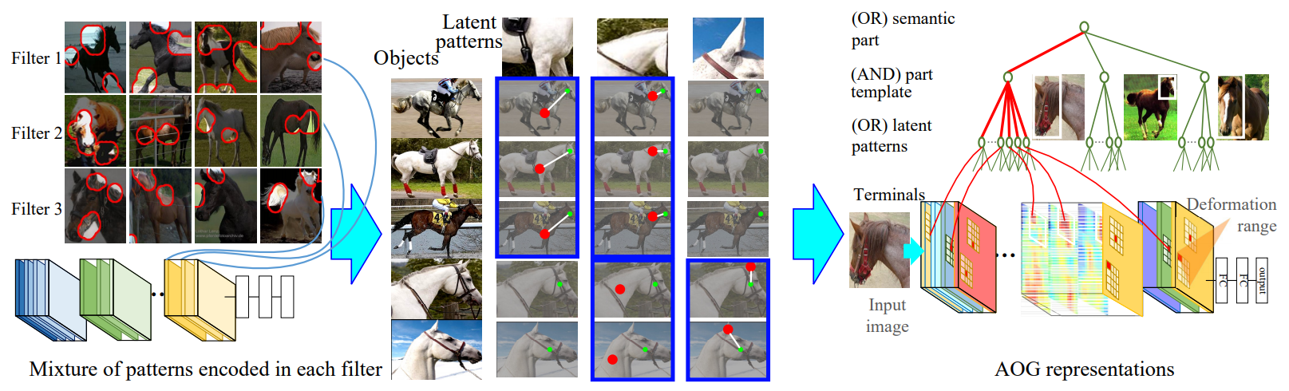

**Figure 2.1:** Mining part-based AOG representations from CNN representations.

The input is a pre-trained CNN and its training samples (i.e., object images without part annotations). The QA method actively discovers the missing patterns in the current AOG and asks human users to label object parts for supervision. In each step of the QA, we use the current AOG to localize a certain semantic part among all unannotated images. Our method actively identifies object images, which cannot fit well to the AOG, i.e., the current AOG cannot explain object parts in these images. Our method estimates the potential gain of asking about each of the unexplained objects, thereby determining an optimal sequence of questions for QA. Note that the QA is implemented based on pre-define ontology, instead of using open-ended questions or answers. As in Figure 2.2, the user is asked to provide five types of answers (e.g. labeling the correct part position when the AOG cannot accurately localize the part), in order to guide the growth of the AOG. Given each specific answer, our method may either refine the AOG branch of an existing part template or construct a new AOG branch for a new part template. Based on human answers, we mine latent patterns for new AOG branches as follows. We require the new latent patterns: (i) to represent a region highly related to the annotated object parts; (ii) to frequently appear in unannotated objects; (iii) to consistently keep stable spatial relationships with other latent patterns. Figure 2.3 visualizes latent patterns in the AOG. It shows that each latent pattern corresponds to a specific part shape through different images.

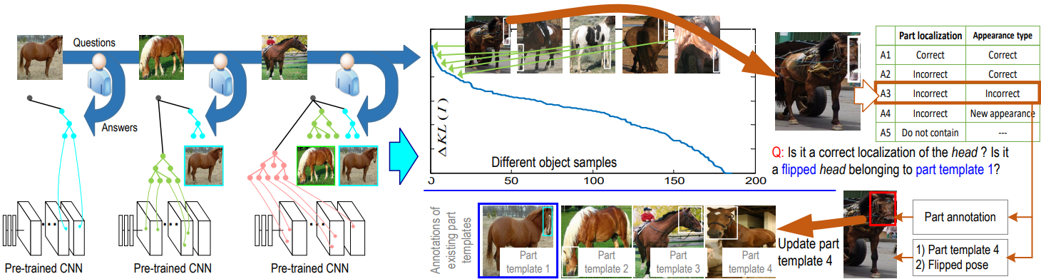

**Figure 2.2:** Learning an AOG to explain a pre-trained CNN via active question-answering

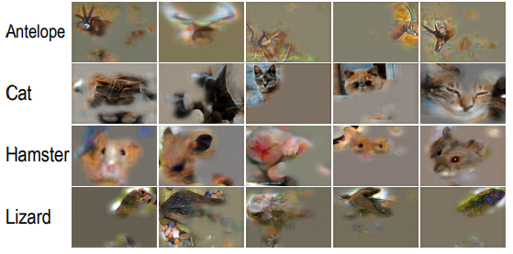

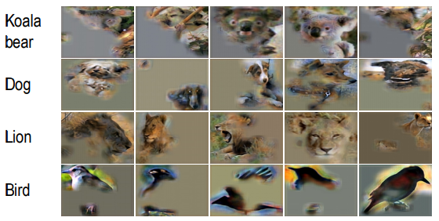

**Figure 2.3:** Visualization of latent patterns in AOGs for the head part

# **Image Analytics: Explaining with Theory-of-Mind**

Generally, X-ToM is an interactive explanation framework inspired from the following three key observations:

1. **Attention is not a Good Explanation**: Previous studies have shown that trust is closely and positively correlated to the level of how much human users understand the AI system --- *understandability* --- and how accurately they can predict the system's performance on a given task --- *predictability*. Therefore, there has been a growing interest in developing explainable AI systems (XAI) aimed at increasing understandability and predictability by providing explanations about the system's predictions to human users. Current works on XAI generate explanations about their performance in terms of, e.g., feature visualization and attention maps. However, solely generating explanations, regardless of their type (visualization or attention maps) and utility, is not sufficient for increasing understandability and predictability. Furthermore, recently, it has been shown that attention weights are frequently uncorrelated with gradient-based measures of feature importance.
2. **Explanation is an Interactive Communication Process**: We believe that an effective explanation cannot be one shot and involves the iterative process of communication between the human and the machine. The context of such interaction plays an important role in determining the utility of the follow-up explanations. As humans can easily be overwhelmed with too many or too detailed explanations, interactive communication process helps in understanding the user and identify user-specific content for explanation. Moreover, cognitive studies have shown an explanation can only be optimal if it is generated by taking the user's perception and belief into account.
3. **Defining a Collaborative Task for the Communication Process**: In our experiments, we found that it is difficult to evaluate the effectiveness of explanations without constraining the communication process. In our framework, we constrain the communication by explicitly defining a collaborative task for the human user to solve through the explanations. Based on how many tasks are successfully solved by the user (and the number of explanations in the dialog), we measure the effectiveness of the explanations.

Based on the above three key observations, we introduce an interactive explanation framework, **X-ToM**. In our framework, the machine generates a sequence of explanations in a dialog which takes into account three important aspects at each dialog turn: (a) human's intention (or curiosity); (b) human's understanding of the machine; and (c) machine's understanding of the human user. To do this, we use Theory of Mind (ToM) which helps us in explicitly modeling human's intention, machine's mind as inferred by the human as well as human's mind as inferred by the machine. The ability to reason about other's perception and beliefs, in addition to one's own perception and beliefs, is often referred to as the Theory-of-Mind. As illustrated in Figure 3.2, we estimate Trust and Reliance in terms of explicit mental states through a dialog.

More specifically, X-ToM has three main components:

1. **Performer** (i.e. a vision or robot system) for complex settings where the Performer’s predictions, plans, or decisions are not readily obvious to the user from one-shot explanations, but require nontrivial sequences of explanations, i.e. a dialogue with the user.

1. **Explainer** that generates maximum utility explanations in a dialog with the user.
2. **Evaluator** that quantitatively evaluates the effect of explanations on the human’s understanding of the machine’s mental model.

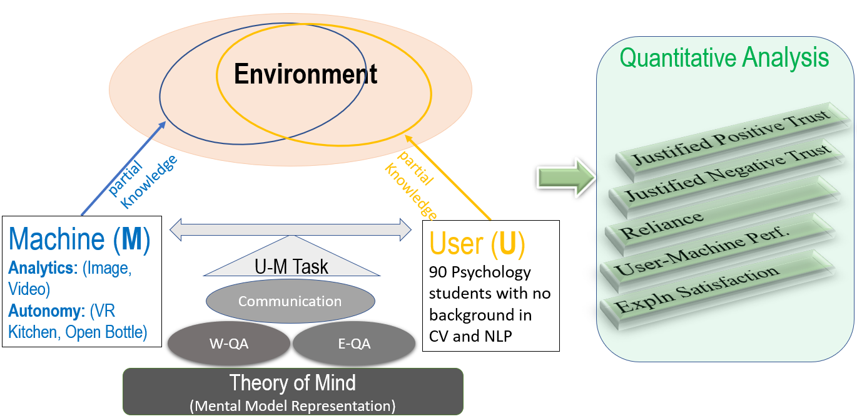

Figure 3.1: X-ToM for optimizing the communication between the machine and user towards estimating and increasing human trust

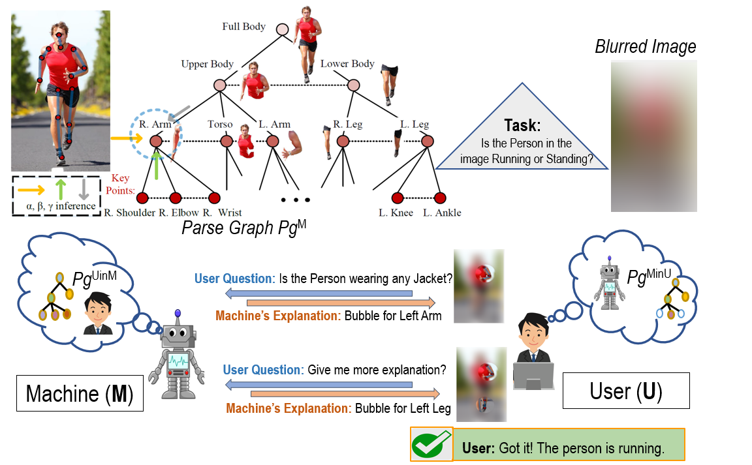

Figure 3.2: XAI as Collaborative Task Solving in Image Analytics.

**Our Hypotheses:**

Compared to the baselines, our X-ToM system users will:

(a) have higher user-machine task performance

(b) have more appropriate trust and reliance in the system

(c) trust and reliance will increase over time: more the number of sessions the users interact with our XAI system, the better is their trust, reliance and user-machine task performance

(d) have a more detailed mental model of the XAI system

(e) more accurately predict the behavior of the XAI system

(f) have more confidence in predicting the behavior of the XAI system

(g) take less time in predicting the behavior of the XAI system

(h) have higher explanation satisfaction and goodness values

(i) need a fewer number of explanations to accurately solve the task

**Metrics and Measures:**

We used the following measures and metrics:

(i) **Positive Trust and Negative Trust:** It is possible for humans to have positive trust (PT) with respect to certain tasks, while having negative trust (NT) (i.e. mistrust) on some other asks. We estimate a user’s mental model of the machine using the Theory of Mind based formulation and define the notion of positive trust and negative trust of humans in the system in terms of the machine’s mental model and user’s understanding of machine’s mental model.

(ii) **Justified Trust and Unjustified Trust**: Both positive and negative trust can be specified in terms of the justified and unjustified trust. We define the notions of justified positive trust (JPT) and justified negative trust (JNT) and measure them quantitatively using our X-ToM.

(iii) **Reliance**: Humans may over-estimate or under-estimate the capability of the machine. Reliance (Rc) captures the extent to which a human can accurately predict the machine’s inference results without over- or under-estimation. More formally, Reliance is a percentage of justified trust over the total positive and negative trust.

(iv) **Number of Explanations**: We use the total number of explanations needed for the user to accurately understand the machine’s mental model as one of the metric to compare the effectiveness of our proposed explanations against the baselines.

(v) **Time**: We record the time needed for the subjects in solving the tasks. We expect that the lesser the time is taken by the subjects in solving tasks, the better is their mental model understanding of the machine.

(vi) **Confidence:** We record the confidence score (from 1 to 5) of the subjects in solving the tasks. These confidence scores are further utilized for scaling up/down the trust and reliance values.

(vii) **Subjective scores of trust and reliance:** In addition to computing the trust and reliance metrics, we prompt subjects to rate their trust and reliance (from 1 to 5). We compare these subjective scores with the quantitative values obtained using X-ToM.

**Participants and Experiment Setup:**

(a) Study type and Participants: This is an in-house study aimed at assessing the effects of the X-ToM Explainer on human understanding of the machine’s mental model. We experimented with 35 human subjects (grad and undergrads) belonging to the Statistics, Computer Science, and Engineering departments.

(b) Study Details: Each human subject is presented with a set of (unblurred) images. For every image, we ask the human subject to predict the machine’s outputs for each of the key inference processes – α, β, and γ. We pose multiple-choice questions and the subject ‘clicks’ on one or more answers. Specifically, there are two main types of questions: (1) Whether the machine would correctly or incorrectly detect object parts and other concepts encoded in the machine’s knowledge base; and (2) Which image parts are most influential for the machine’s correct or incorrect object detection. For example, the questions include “which parts of the image are most important for the machine to recognize that the person is running”, and “which part of image contributes most to inferring the surrounding larger part of the image”. Each subject performs two tasks in 4 to 5 sessions. We also analyze the gains in trust and reliance values after each session.

**Experimental Results and Analysis:**

Table 3.1 shows a comparison of our X-ToM with the two baselines (QA and Attention Maps) using the aggregated results from our experiment. As we can see, the no explanation baseline (QA), Attention baseline, and X-ToM are all found to have high PT and NT values. However, the justified PT, justified NT and Reliance values of X-ToM are significantly higher than others. Also, attention maps did not perform any better than the no explanation baseline in terms of JPT, JNT, and Rc. User-Machine task performance and explanation satisfaction measured in terms of understandability accuracy, usefulness and appropriate detail are higher for X-ToM relative to baselines. It may be noted that user confidence was found to be high both in X-ToM experiment setup as well as the baselines.

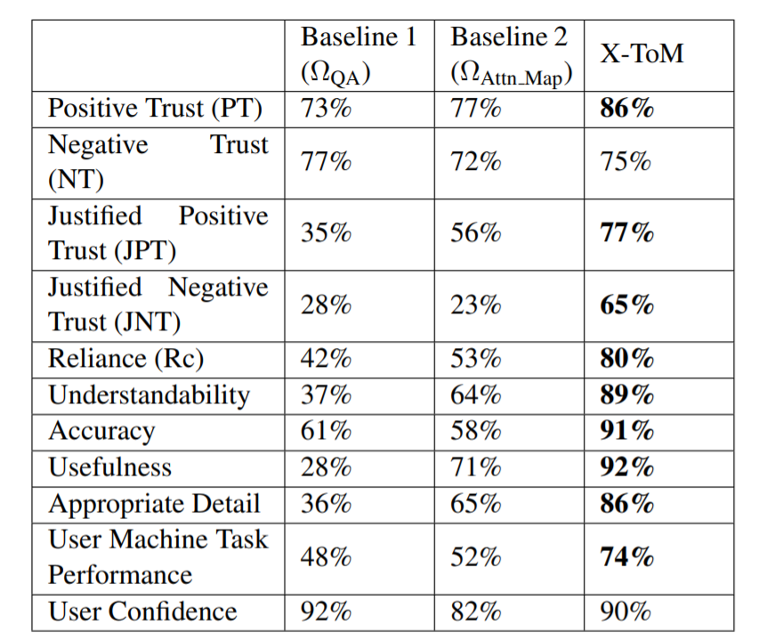

**Table 3.1**: A comparison of our X-ToM with the two baselines (QA and Attention Maps) using the aggregated results from our experiment

We found that the confidence scores of subjects are not very helpful in assessing their understanding of the machine and trust values. Therefore, we ignore the subjective confidence scores while computing the trust and reliance values. Also, we control the time spent by the subject in solving the task. Subjects interacting in X-ToM setting and the baselines are given the same amount of time per task.

We ran ANOVA to examine if the results obtained from different models are significantly different. We also performed a post-hoc comparison with Bonferroni correction. As we expected, X-ToM leads to significantly higher values of justified positive trust, justified negative trust, reliance, and user-machine task performance compared to the baselines. However positive trust, negative trust and confidence scores of X-ToM are not found to be significantly different from the baselines.

**Our Experiments with Psychology Subject Pool**

Using X-ToM Evaluator, we conduct human subject experiments to assess the effectiveness of the X-ToM Explainer, that is trained on AMT, in increasing human trust through explanations. We recruited 120 human subjects from our institution’s Psychology subject pool. As illustrated in Figure 3.3, these subjects have no background on computer vision, deep learning, and NLP.

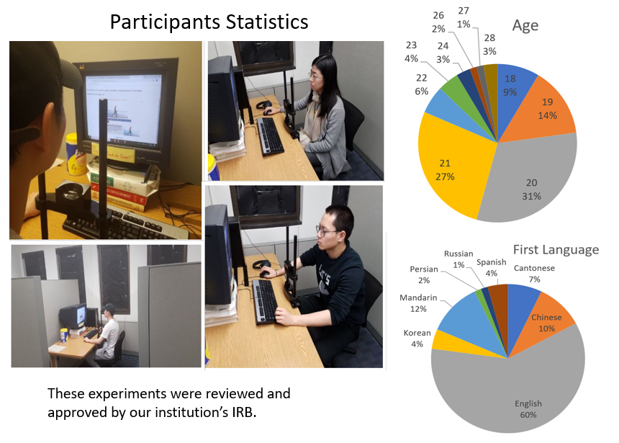

**Figure 3.3**: The statistics of the participant subjects

We applied between-subject design and randomly assigned each subject into one of the three groups. One group used X-ToM Explainer, and two groups used the following two baselines respectively.

• ΩQA: we measure the gains in human trust only by revealing the answers for the tasks without providing any explanations to the human.

• ΩSalience: in addition to the answers, we also provide saliency maps generated using attribution techniques to the human as explanations

Within each group, each subject will first go through an introduction phase where we introduce the tasks to the subjects. Next, they will go through the familiarization phase where the subjects become familiar with the machine’s underlying inference process (Performer), followed by a testing phase where we apply our trust metrics and assess their trust in the underlying Performer.

As depicted in Figure 3.4, we compare the justified positive trust (JPT), justified negative trust (JPT), and Reliance (Rc) of X-ToM with the baselines. As we can see, JPT, JNT and Rc values of X-ToM are significantly higher than ΩQA and ΩSalience (p < 0.01). Also, it should be noted that attribution techniques (ΩSalience) did not perform any better than the ΩQA baseline where no explanations are provided to the user. This could be attributed to the fact that, though saliency maps help human subjects in localizing the region in the image based on which the performer made a decision, they do not necessarily reflect the underlying inference mechanism. In contrast, X-ToM Explainer makes the underlying inference processes (α, β, γ) more explicit and transparent and provides explanations tailored for individual user’s perception and understanding.

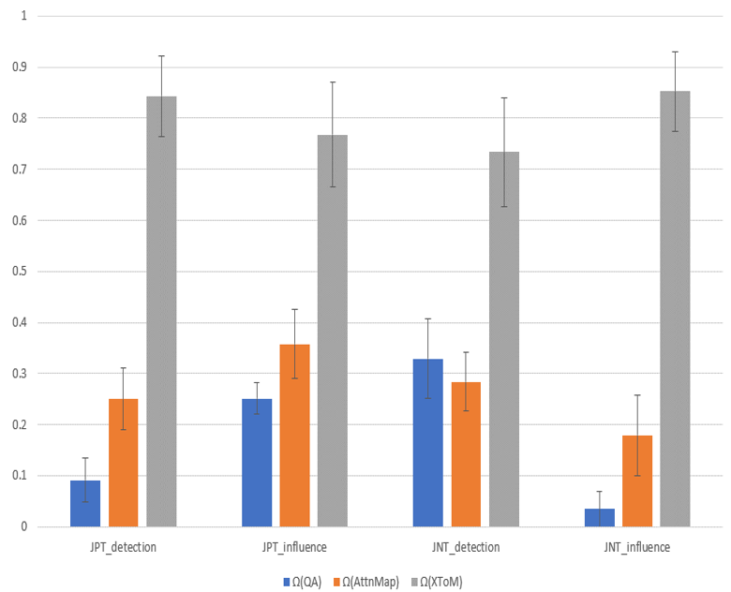

**Figure 3.4**: The comparison the justified positive trust (JPT), justified negative trust (JPT), and Reliance (Rc) of X-ToM with the baselines

Therefore X-ToM leads to the significantly higher values of JPT, JNT and Rc. This is one of the key results of our work, given the popularity of attribution techniques as the state-of-the-art explanations.

In Figure 3.5, we show the average explanation satisfaction rates obtained from each of the three groups. As we can see, subjects in X-ToM experiment group found that explanations were highly useful, sufficient and detailed compared to the baselines (p < 0.01). Interestingly, we did not find significant differences across the three groups in terms of other satisfaction measures: confidence, understandability, accuracy, and consistency. We leave this observation for future exploration.

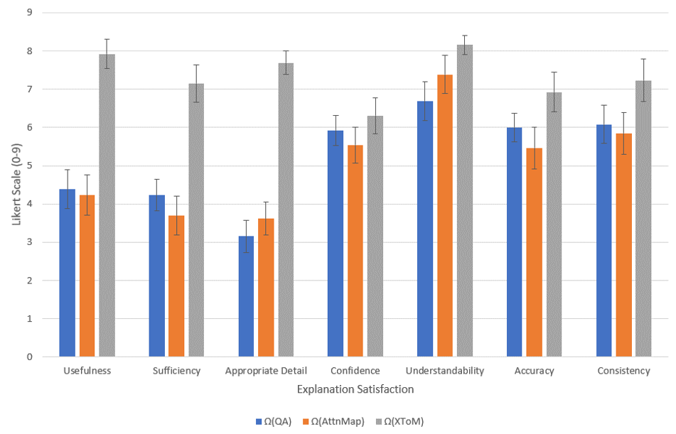

**Figure 3.5:** The average explanation satisfaction rates

We hypothesized that human trust and reliance in the machine might improve over time. This is because it can be harder for humans to fully understand the machine’s underlying inference process in one single session. Therefore, we conduct an additional experiment with eight human subjects where the subjects’ reliance is measured after every session. The results are shown in Figure 3.6. As we expected, the subjects’ reliance increased over time. Specifically, reliance with respect to α inference process significantly improved only after 2.5 sessions. Reliance with respect to β and γ inference processes significantly improved after 4.5 sessions. It is clearly evident that, with more sessions, it is possible to further improve human reliance in the AI system.

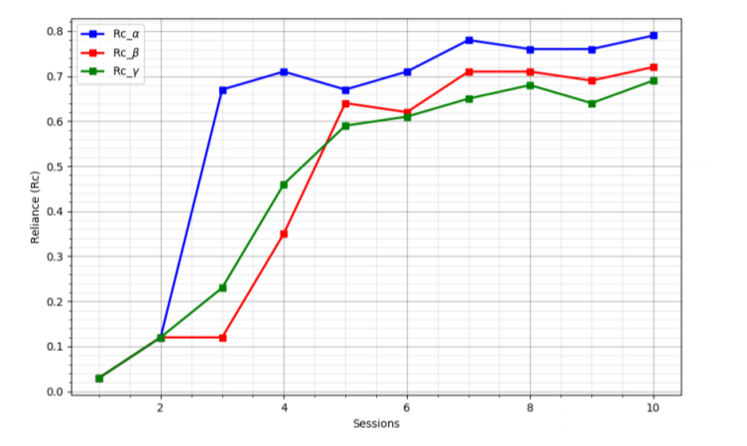

**Figure 3.6:** Thesubjects’ reliance per every session

In addition to the quantitative and qualitative metrics discussed above, we also measure the following metrics for comparing our X-ToM framework with the baselines:

1. **Response Time:** We record the time taken by the human subject in answering evaluator questions. Figure 3.7 shows the average response times (in milliseconds per question) for each of the three groups (X-ToM, QA and Saliency Maps). We expected the participants in X-ToM group to take less time to respond compared to the baselines. However, we find no significant difference in response times across the three groups.

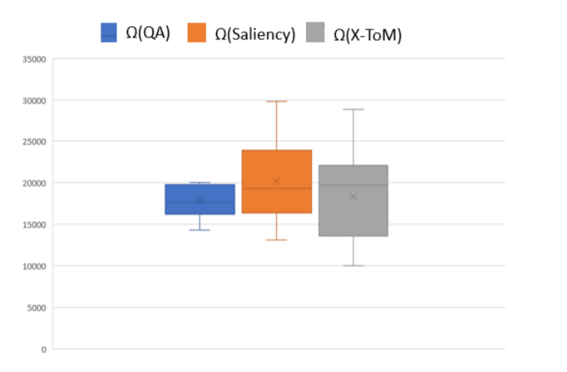

**Figure 3.7**: The average response times (in milliseconds per question) for each of the three groups (X-ToM, QA and Saliency Maps).

1. Subjective Evaluation of Reliance: We collect subjective Reliance values (on a Likert scale of 0 to 9) from the subjects in the three groups. The results are shown in Figure 3.8. These results are consistent with our quantitative reliance measures. It may be noted that subjects’ qualitative reliance in Saliency Maps is lower compared to the QA baseline.

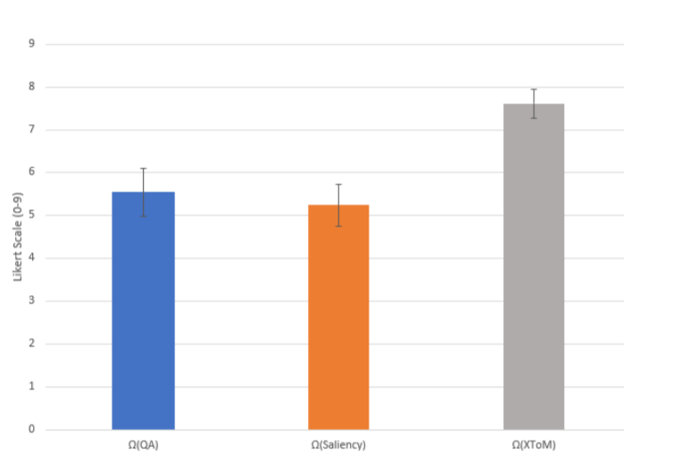

**Figure 3.8**: The subjective Reliance values (on a Likert scale of 0 to 9) from the subjects in the three groups

**X-ToM Evaluator Interface and Questions:**

Specifically, there are two main types of evaluator questions about the user prediction: (1) whether the Performer would successfully or incorrectly detect objects, parts and other concepts encoded by AOG; and (2) which image parts are most influential for the Performers successful or incorrect object detection. For example, the evaluator’s questions include “which parts of the image are most important for the machine to recognize that the person is running”, and “which small part of image contributes most to inferring the surrounding larger part of the image”. Figure 3.9 shows several sample screenshots (from our web interface) of the exact questions, on the detection of the body part “Left-Arm”, that we pose to the subjects.

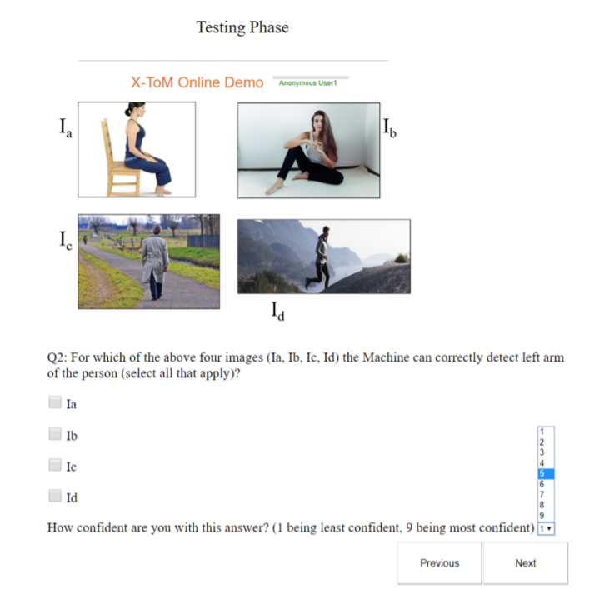

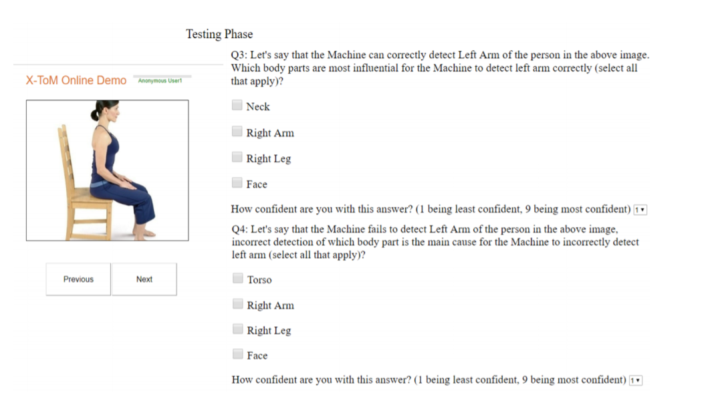

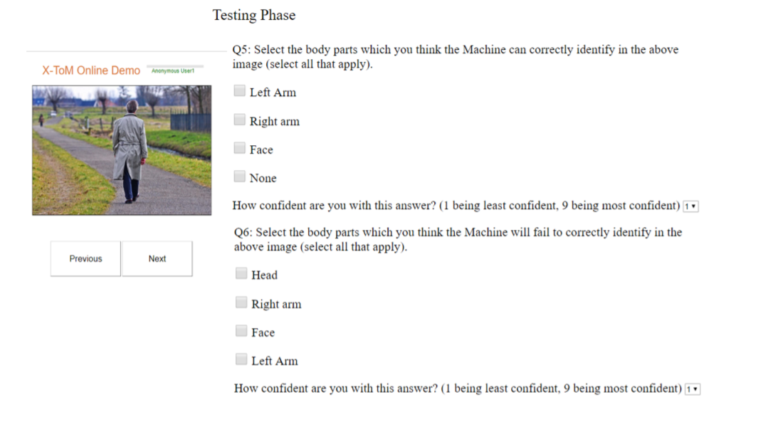

**Figure 3.9**: Three example screenshots (from our web interface) of the exact questions

# **Image Analytics: Fault-Lines**

We present CoCo-X (short for Conceptual and Counterfactual Explanations), a model for explaining decisions made by a deep convolutional neural network (CNN). We do this by introducing the notion of concept-level explanations by adapting a Cognitive Psychology concept, called ***Fault-Lines***, to computer vision domain. Fault-lines are the high-level semantic aspects of reality that humans zoom in on when they imagine an alternative to it. More concretely, given an input image I for which a CNN model M predicts class $C_{pred}$, our fault-line based explanation identifies a minimal set of semantic features, referred to as explainable concepts (*xconcepts*), that need to be added to or deleted from I in order to alter the classification category of I by M to another specified class $C_{alt}$.

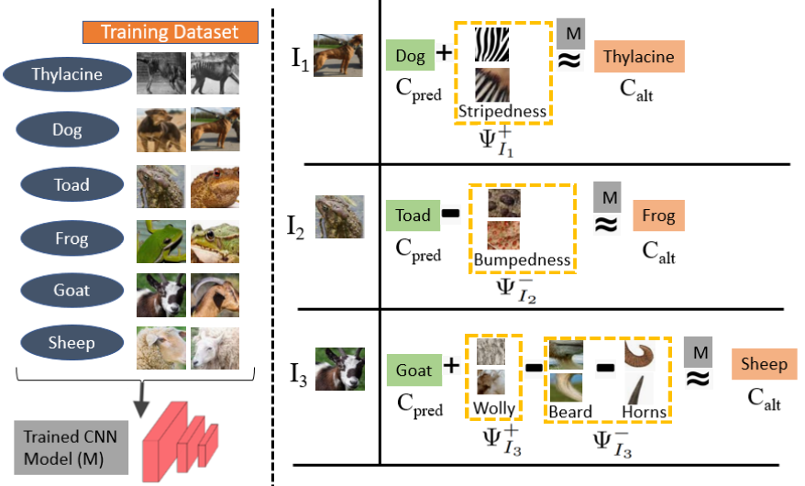

**Figure 4.2**: The example explanation using our proposed fault-lines.

For example, let us consider a training dataset for an image classification task shown in Figure 4.2. In order to alter the model's prediction of input image $I_{1}$ from Dog to Thylacine, the positive fault-line suggests adding stripes to the Dog. We call this a positive fault-line (PFT) as it involves adding a new xconcept, i.e., stripedness, to the input image. Similarly, to change the model prediction of $I_{2}$ from Toad to Frog, the negative fault-line suggests removing bumps from the Toad.

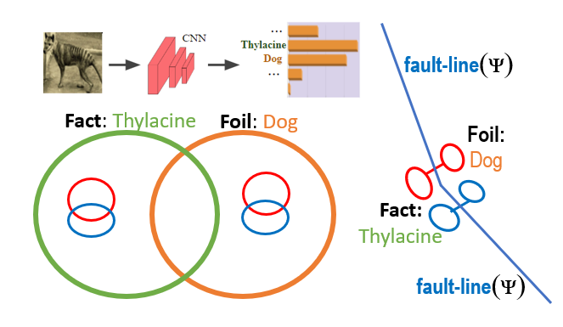

Figure 4.2.1: Fault-line Illustration.

As we can see, these fault-lines (Figure 4.2.1) can be directly used to make the internal decision-making criteria of deep neural network transparent to both expert and non-expert users. For instance, we answer the question “Why does the machine classify the image $I_{2}$ as Goat instead of Sheep” by using PFT and NFT as follows: “Machine thinks the input image is Goat and not Sheep mainly because Sheep's feature woolly is absent in $I_{3}$ and Goat's features beard and horns are present in $I_{3}$”.

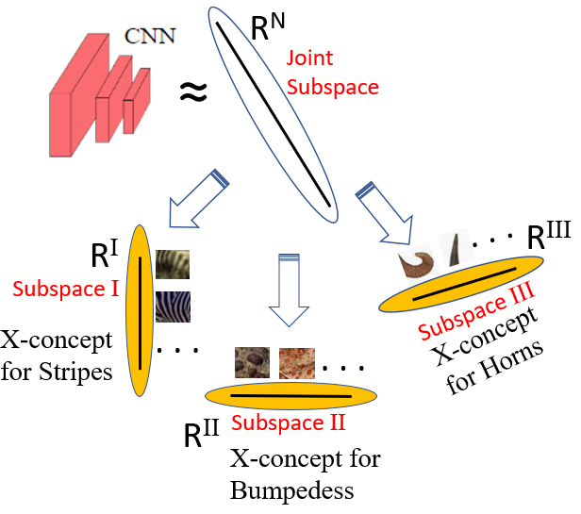

**Figure 4.2.2**: Xconcepts as finding subspaces.

**DoD Relevance**

This project focuses on explaining human-aligned (i.e., conceptual) counterfactual factors (called fault-lines) of underlying model decisions to human. Our framework can be integrated into explanation frameworks that require detection of most influential, interpretable, human-aligned aspects/factors between two class of objects. One such scenario would be the detection of enemy/rival group vs ordinary civilians. In this example, our framework would help in learning and aligning the concept of targeted rival/enemy group vs civilians. Furthermore, by explaining such explicit counterfactual and concept-level dependencies to the user, our framework minimizes effort in trusting (both positively and negatively) the model’s decision.

**Extracting Xconcepts**

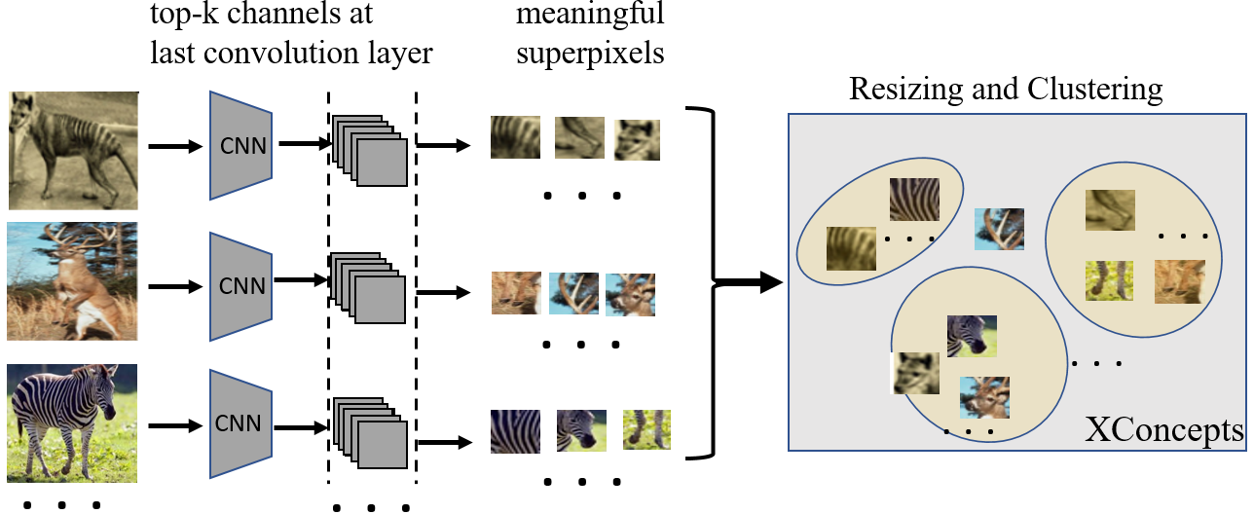

**Figure 4.3**: Generation of Xconcepts

As deeper layers of the CNN capture richer semantic aspects of the image, we construct xconcepts by making use of feature maps from the last convolution layer. We consider each feature map as an instance of an xconcept and obtain its localization map (i.e., super-pixels of each feature map). To produce the localization map, we use Grad-CAM to compute the gradients of $y^{c}$ with respect to the feature maps and are then spatially pooled using Global Average Pooling (GAP) to obtain the importance weights of a feature map $m$ at layer $L$ for a target class $c$ (shown in Figure 4.3).

**Identifying Class-Specific Xconcepts**

For each output class $c$, we learn the most common xconcepts that are highly influential in the prediction of that class over the entire training dataset. We use the TCAV technique to identify these class-specific xconcepts.

**Fault-Line Identification**

We formulate finding a fault-line explanation as the following optimization problem:

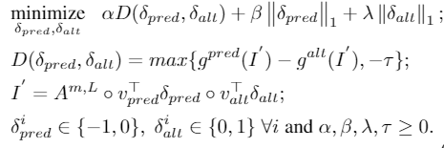

Our goal here is to derive a fault-line explanation that gives us the minimal set of xconcepts that will alter the model prediction from $c_{pred}$ to $c_{alt}$. Intuitively, we try creating new images ($I'$) by removing/adding xconcepts from/to $I$ until the classification result changes from $c_{pred}$ to $c_{alt}$. To do this, we do not directly perturb the original image but change the activations obtained at last convolutional layer instead.

**Experiments and Results**

We conducted human studies to assess the effectiveness of our CoCo-X explanations. We also performed extensive in-person evaluations on the following two subject pools: UCLA Psychology and UCLA Communication. The study is approximately one hour. Participants received 1hr of course credit for participating. We applied between-subject design and randomly assigned subjects into control and experiment groups. Within each group, each subject will first go through an introduction phase followed by a familiarization phase where the subjects become familiar with the underlying model through explanations, followed by a testing phase where we apply our evaluation metrics and assess their understanding in the underlying model.

**Results for CoCo-X (on Image Classification Task)**

Justified Trust is computed by evaluating the human's understanding of the model's (M) decision-making process. In other words, given an image, it evaluates whether the users could reliably predict the model's output decision. As shown in the below table, Justified Trust (JT) values of attention-map-based explanations such as Grad-CAM do not differ significantly from the NO-X baseline, i.e., attention-map-based explanations are not effective at increasing human trust and reliance. It may also be noted that concept-based explanation frameworks TCAV and counterfactual explanation frameworks CEM and CVE performed significantly better than NO-X baseline (in both expert and non-expert pool). Our CoCo-X model, which is both conceptual and counterfactual, significantly outperformed all the baselines with 69.1% JT in non-expert pool and 70.5% JT in expert pool (*p* < 0.01).

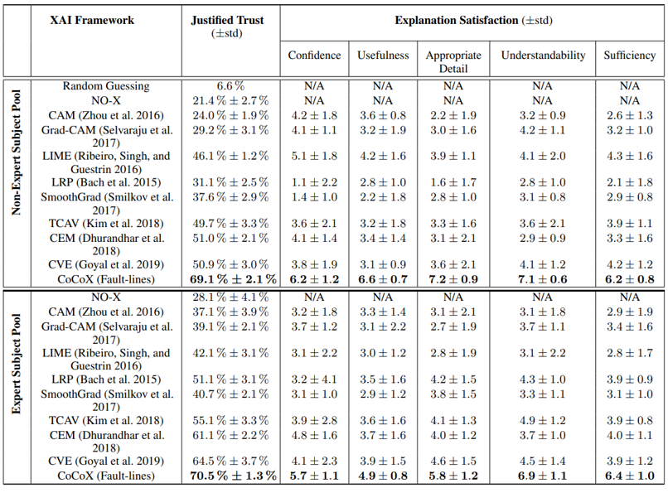

# **Video Analytics: GTA5 Autonomous driving platform**

In this task, we focus on exploring how our proposed Counterfactual Explanation with Theory-of-Minds (CX-ToM) XAI framework can obtain increased justified trust and reliance from human subjects by providing a wide range of explanations. Specifically, compared to the baselines, we will test whether if our CX-ToM explanations achieve:

1. More appropriate user trust and reliance within a limited time?
2. High gains in trust and reliance over time?
3. Less time in accurately predicting the behavior of the machine with more confidence?

To provide better explanations that improve user-machine performance, we have developed a new type of explanation so-called “behavior fault-line” for interpreting the perception and policy of our proposed CX-ToM framework. This new explanation has been integrated into our system as an explanation interface for video data analytics. Recently, various self-driving systems have been proposed and achieved promising results. However, it is difficult for users to comprehensively identify whether the machine can be trusted in terms of pedestrians and vehicles along the road. Furthermore, it is extremely difficult for the user to understand the latent policy/rule of the machine, making establishing and improving their trust and reliance to the machine difficult. Therefore, to address this issue and extend our proposed CX-ToM, we have constructed a visual autonomous-driving platform via the GTA5 game platform. Intuitively, an autonomous-driving platform is an ideal test case due to the following two aspects: i) it supports the machine and the user collaborating with each other seamlessly; ii) it provides time pressures for both the machine and user. Within a limited time, the user needs to predict the behavior of the machine and determine when the machine can be trusted.

**Counterfactual X-ToM Explanation Framework on the GTA5 Platform**

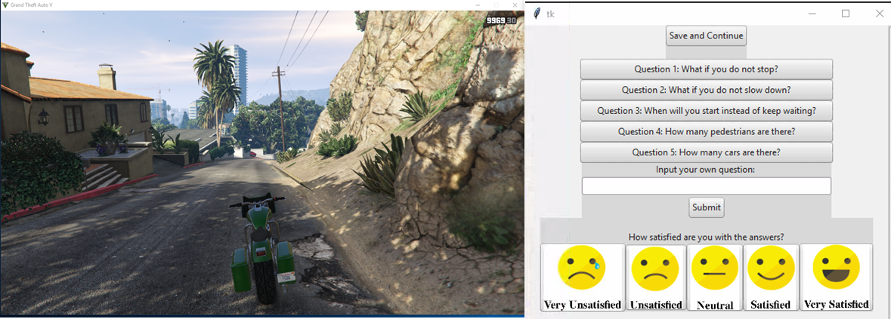

**Figure 5.1**: The user interface of our CX-ToM framework on the GTA5 platform.

As illustrated in Figure 5.1 and Figure 5.2, our CX-ToM framework first parses the game scenario into a Spatio-Temporal Parsing Graph (ST-PG) in real-time. Next, CX-ToM performs user mental modeling through the user-machine dialogue with our introduced self-diagnostic mechanism. Specifically, our CX-ToM framework focuses on generating a uniform and consistent explanation in the form of the probabilistic spatio-temporal parse graph (ST-PG) representation and symbolic reasoning.

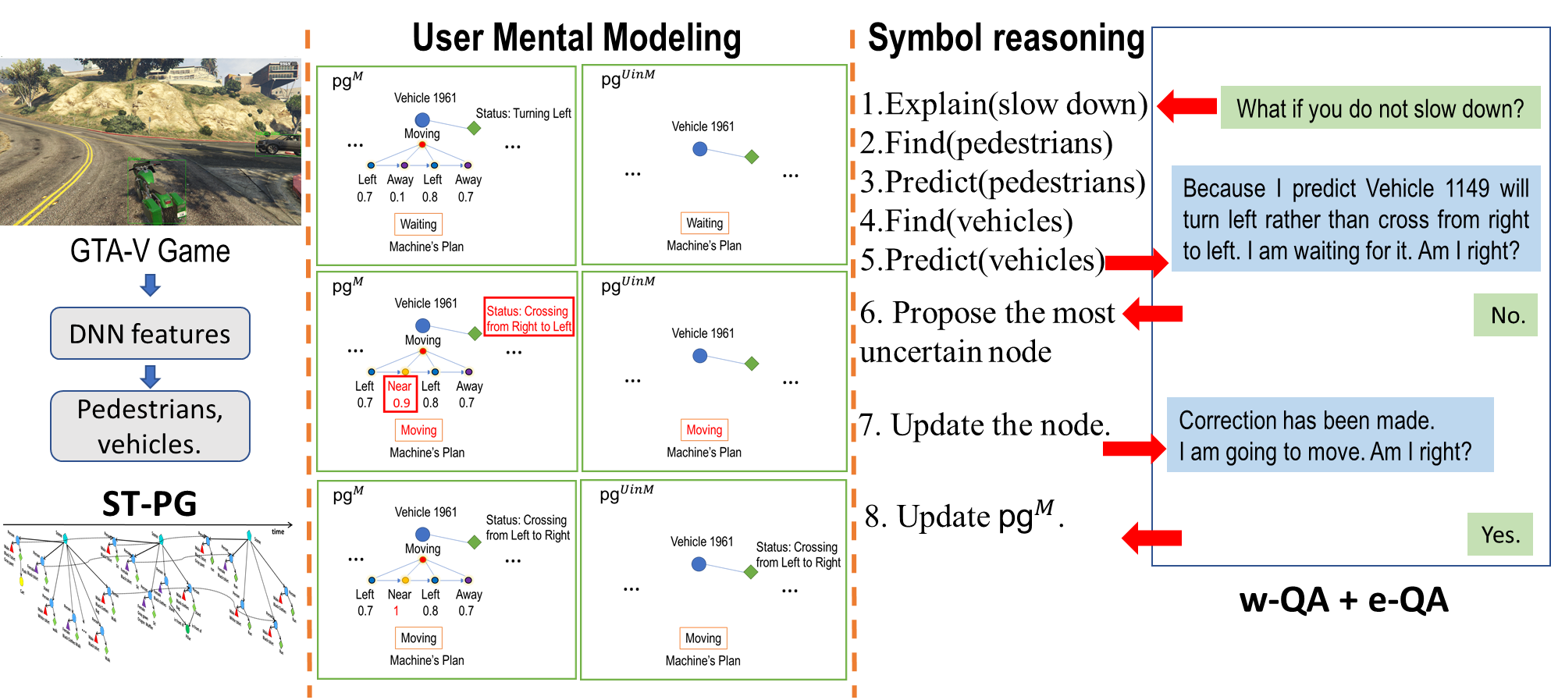

**Figure 5.2**: The illustration of how our CX-ToM framework works on the GTA5 game platform.

**DoD Relevance**

This project focuses on human-machine teaming for both video analytics and autonomy research. Specifically, we investigate on how the machine can collaborate with a human partner to drive a motorbike from Place A to Place B in GTA5. Our framework might be directly applied to some special missions, e.g., driving an armored vehicle or controlling an autonomous vehicle. The possible benefits to DoD would be:

1. Enabling the user to decrease the time necessary to accurately predict machine behavior and do so with more confidence.
2. Enabling user trust and reliance within a limited timeframe and avoid over-trust or zero-trust towards the machine.

**Performer**

In Phase II, we attempt to overcome limitations of the convolutional operation and implicitly learn the visual grammar for decomposing the input image and feature map into a hierarchical representation. Figure 5.3 is a typical example of how a scene image (sampled from ImageNet) can be parsed into a hierarchical tree with nodes representing regions (e.g., a dog, a person, or a region of interaction “hugging”) and edges representing the relation between different regions. As shown, the parse tree covers a variety of visual concepts, including objects (i.e., dog and person), actions (i.e., hug), and background (i.e., “bkg”), which accord with human perception. The corresponding heatmap denotes the parsed visualization.

We propose a novel tree convolution (TreeConv) operation for improving CNNs via the guidance of visual grammars within each DNN layer. Specifically, our TreeConv includes three main steps: i) parsing the input feature maps by using constituency trees via a top-down parsing; ii) resizing the tree nodes to different scales for redundancy reduction and convolving them by vanilla convolutions; iii) fusing the convolved nodes from the bottom up to form the output feature maps. Figure 5.4 illustrates the above three steps. According to our observation, the hierarchical features seem to be ordered regularly, i.e., they are sorted by the fineness, implying there may be some knowledge of visual grammar implicitly learned by our model. Moreover, as a by-product, the automatically sorted hierarchical features enable us to reduce the redundancy of the input feature maps and thus greatly reduce the computational cost compared with the vanilla convolution.

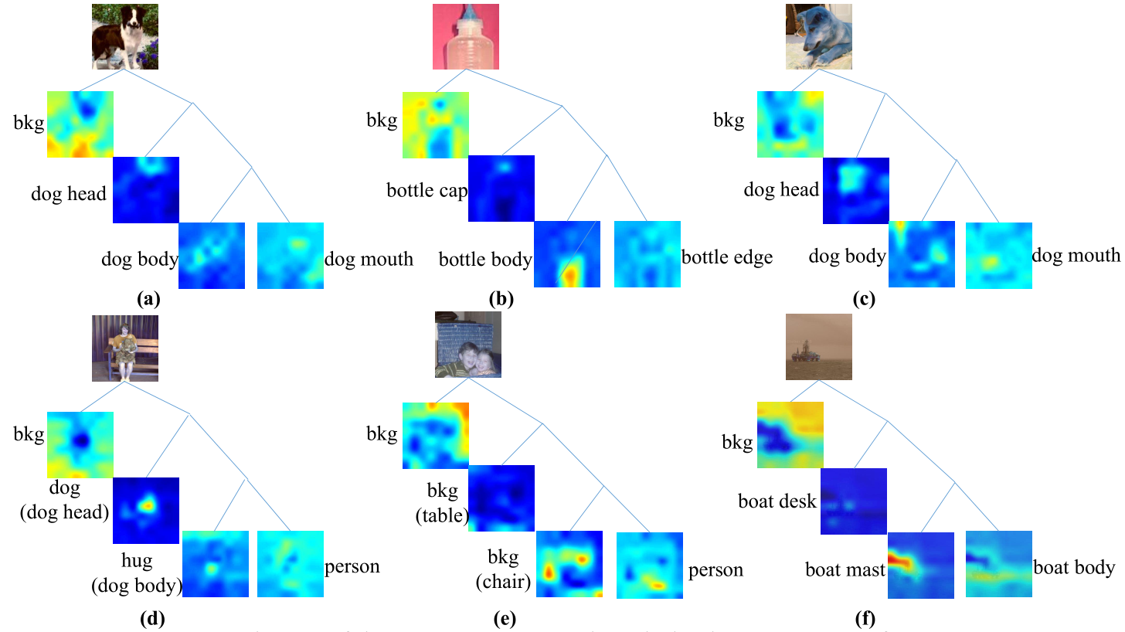

**Figure 5.3**: The implicitly learned parse trees of Performer by grammatically recognizing images.

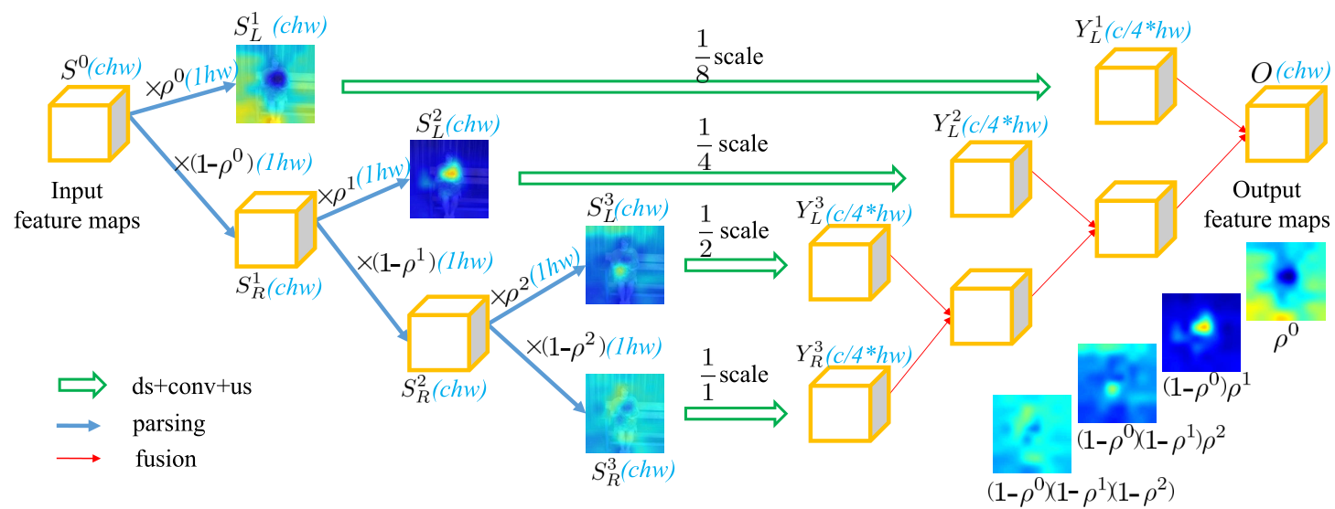

**Figure 5.4**: An overview of our TreeConv operation.

Figure 5.5 presents how the performer of our framework generates the ST-PG representations. Specifically, given the input video data, the performer first detects and tracks the pedestrians and vehicles along the road in such a real-time fashion. Then, the performer generates the ST-PG representations based on the detection and tracking results under the guidance of predefined ontology graphs.

The explanations provided by our ST-PG representations are important for a few reasons. Firstly, the ST-PG representation consists of nodes that are grounded to concrete portions of the scene. Secondly, because of the hierarchical structure of the ST-PG, we can trace through the parse graph to provide answers to the user. Finally, because the ST-PG must adhere to a predefined ontology, we have guarantees about the overall structure of the parse graph. These properties enabling providing consistent explanations to human users.

Thus, the explanations provided by our ST-PG representations allow for easy derivation of their self-explainability and consistency; *i.e.* ST-PG representation enable recording the detected atomic actions and motion status of the corresponding vehicle. Explanations as ST-PG representations with nodes grounded to concrete data segments serve as a self-explanatory trace of how answers are derived. Also, these explanations are guaranteed to be consistent as each ST-PG representation is guaranteed to respect all constraints in the predefined ontology.

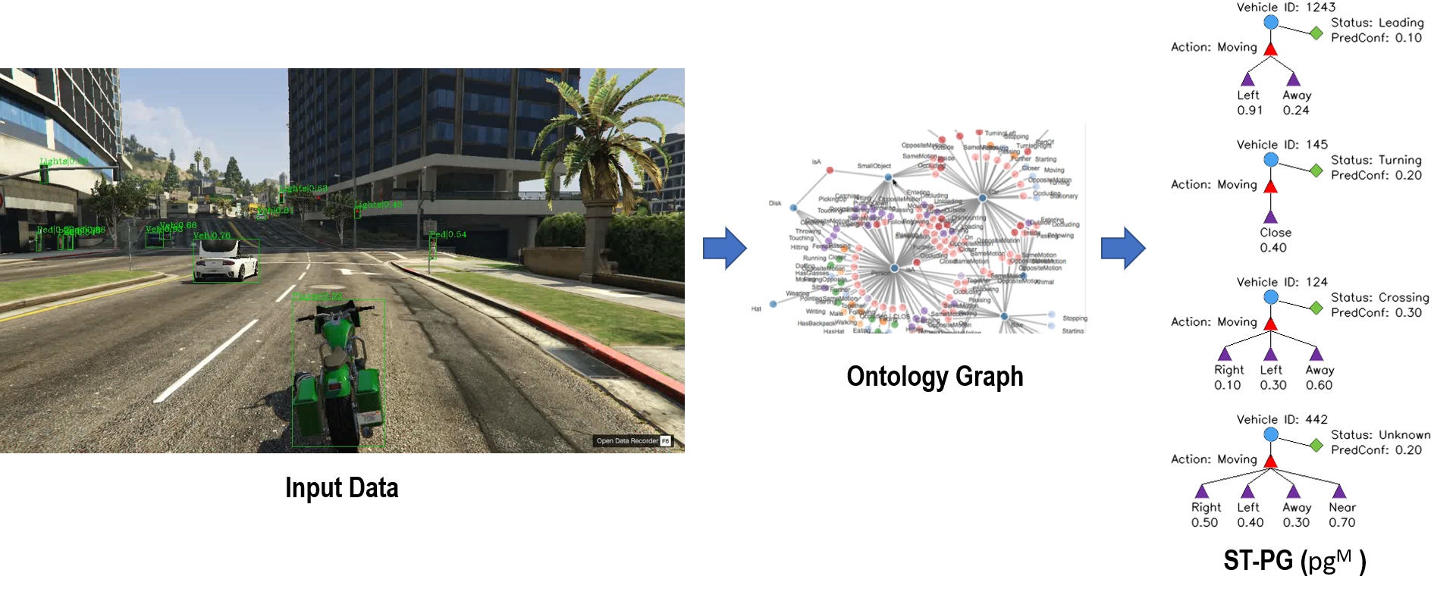

**Figure 5.5**: The illustration of how the performer of our CX-ToM framework generates the ST-PG representations by online detecting and tracking pedestrians and vehicles along the roads.

**Explanation Generation via Behavior Fault-lines**

As illustrated in Figure 5.6, the explainer of our CX-ToM framework generates two types of explanations: i) explaining the recognition results about the pedestrians/vehicles and their behaviors; ii) explaining the driving decisions, i.e., behavior fault-lines, which concentrate on distinguishing different behaviors of vehicles and pedestrians based on a series of atomic actions. For instance, Figure 5.7 depicts that the machine can explain why it thinks that the vehicle in front turns left rather than goes straight.

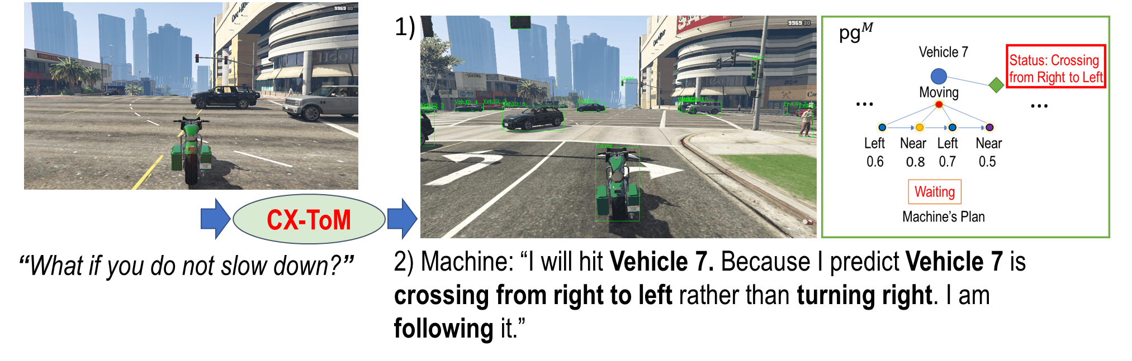

**Figure 5.6**: The illustration of how the explainer of our CX-ToM framework generate two types of explanations.

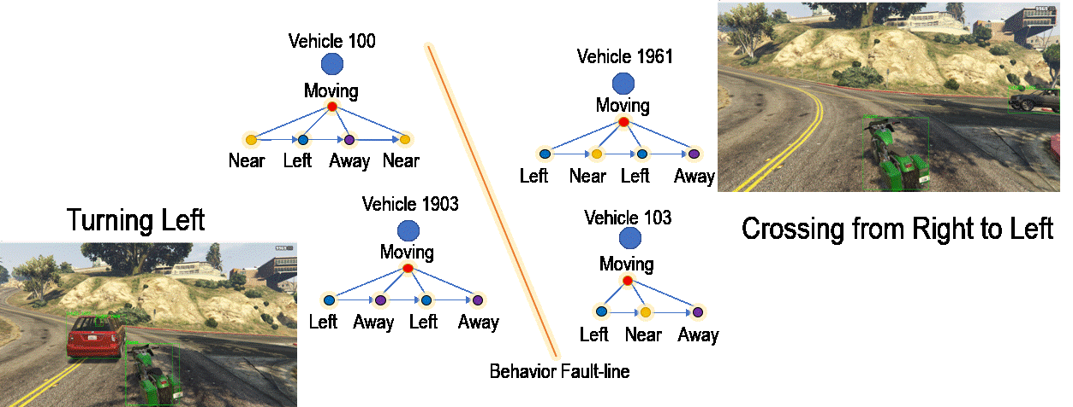

**Figure 5.7**: An example of the behavior fault-line for identifying the turning left and crossing from right to left behavior.

**User Mental Modeling via Self-diagnostic Mechanism**

Our CX-ToM framework performs user mental modeling according to the behavior fault-line and our introduced self-diagnostic mechanism. Specifically, our CX-ToM framework can infer how the user understands the machine according to the provided behavior fault-line explanation through the dialogue. Figure 5.8 demonstrates how our CX-ToM framework performs according to the user feedback. If the user gives negative feedback, our CX-ToM framework performs self-diagnosis by changing the most uncertain node of the ST-PG representation to update its explanation. On the other hand, if the user gives positive feedback, our CX-ToM framework updates the uncertain node of the ST-PG representation to reduce the uncertainty its explanation.

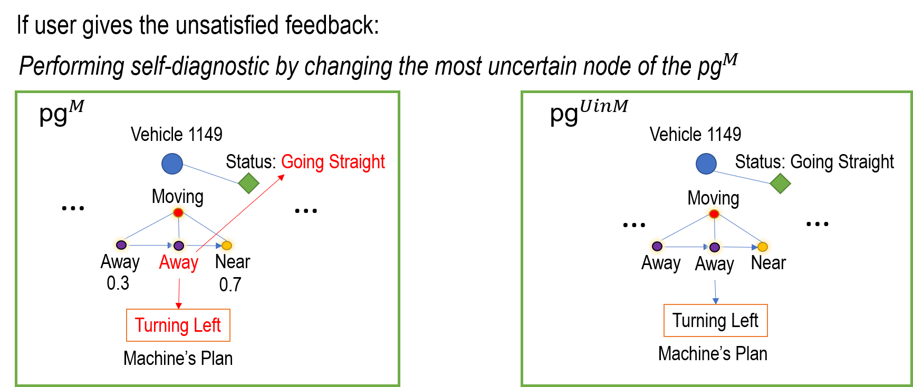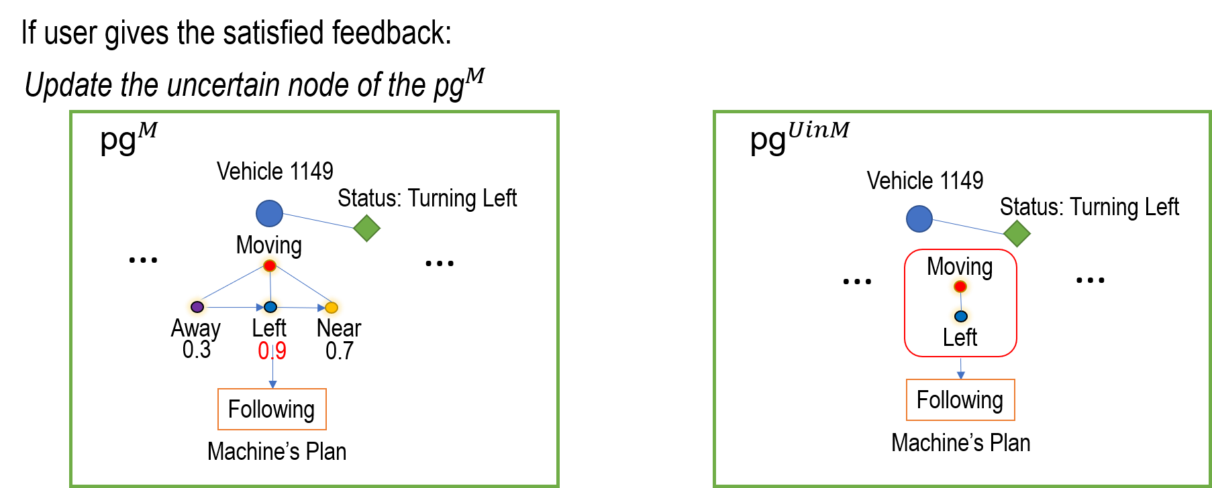

**Figure 5.8**: The illustration of how our CX-ToM framework performs user mental modeling according to the behavior fault-line and our introduced self-diagnostic mechanism.

**Experimental Settings**

To justify the effectiveness of our CX-ToM framework on the GTA5 autonomous driving scenario, we conducted the experiment with participants the following two subject pools: UCLA Psychology and UCLA Communication. Experiments are still in progress, but due to the COVID pandemic, we are reassessing how to continue with digital subject pools. We record their gender, age, and driving experience. The experiment consists of three stages: i) introduction, ii) familiarization, iii) testing. In the introduction stage, the user is provided with a basic understanding of the experiment (10 min). During the familiarization stage, the user becomes familiar with the game control (20 min). In the final testing stage, the user and machine need to collaboratively work with each other to drive the motorbike to the destination. After these stages, the user is asked to perform a post-experiment survey, as shown in Figure 5.9.

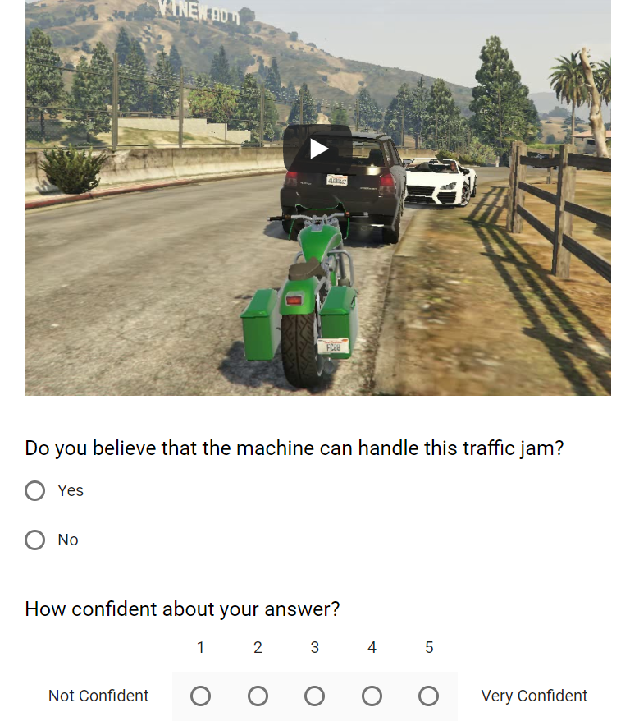

**Figure 5.9**: The example questionnaire of the post experiment survey.

**Hypotheses**

Through our user study experiments, we have tested the following hypotheses:

* 1. Our introduced behavior fault-lines that are counterfactual in nature obtain higher user trust, reliance and satisfaction over time compared to the baselines.
  2. Machine can obtain higher degrees of trust by providing a machine self-diagnostic mechanism.
  3. User-Machine task performance can be increased as a result of improved explanations and user mental modeling.

**B User-Machine Task**

In this GTA5 game platform, the user-machine task is defined as follows:

1. Both the user and the machine need collaboratively to drive the motorbike from place A to B. Note that the machine knows the shortest path, but it has limited ability to recognize pedestrians and vehicles along the road and predict their behaviors. This provides an incentive for the user and machine to collaborate.
2. The machine controls the motorbike by default while the user can take the control manually.

**C Manipulated Variables**

The experiment exploits a between-subject design for the user study. Specifically, all the users are randomly assigned to one of the following five groups.

**Control Group (CX-ToM, no explanations to user)**: Users would not obtain any explanations. They can only predict machine behavior according to their educated guesses based on the previous behavior of machine. Note that, in this group, the machine also performs behavior fault-line modeling and self-diagnostic mechanism but will not show this explanation to the user.

**Experiment Group (CX-ToM)**: Users can obtain the explanation provided by our CX-ToM Framework through the user-machine dialogue.

**Ablation Study Group** **I (CX-ToM, no self-diagnostic)**: Users can obtain the explanation provided by our CX-ToM without our proposed self-diagnosis for user mental modeling. This means that users can only receive the explanations that will not be adaptively updated according to their feedback.

**Ablation Study Group** **II (X-ToM)**: Users can obtain the explanation provided by our CX-ToM without behavior fault-lines. This means that users are only shown with the explanation provided by our previous X-ToM system.

**D Evaluation Metrics**

We employ the following evaluation metrics to measure the user’s perception of explanation, machine learning performance, and user-machine task performance.

**User-Machine Task Performance (***The less, the better***):** How long is needed to complete the task?

**Justified Positive/Negative Trust (***The more, the better***):** The correct prediction of machine behavior from the user.

**User Idle Time (***The more, the better***):** The percentage of machine driving time over the task execution time. This is an objective metric to measure whether the user trust the machine.

**Explanation Satisfaction (***The more, the better***):** The percentage of user facial happiness over other non-neutral facial expressions during the user-machine task.

**Mental Model Understanding (***The less, the better***):** The number of dialogue-turns with the user.This implies how well the machine can address the user’s concern.

**Explanation Goodness (***The more, the better.***):** The Likert scale of user for the explanation provided by the machine.

**Experimental Results and Analysis**

In our current experiment, we have recruited 60 subjects for our IRB-approved study from the UCLA Psychology and UCLA Communication subject pool. Nearly half of the participants came from a non-STEM background. About 83.3% of them have driving experience. Their reported ages range from 18 to 27. Each participant received 1hr of course credit for completing the study.

We first present whether our CX-ToM framework can improve the explanation satisfaction and goodness. As shown in Figure 5.10 and Figure 5.11, the experiment group can achieve a much higher user Likert scale and percentage of happiness compared with the control group. These results show that the generated explanation of our CX-ToM framework is beneficial.

For analyzing the benefit of understanding the user mental model, Figure 5.12 illustrates that the experiment group can obtain significantly fewer dialogue turns compared to the control group. This implies that explanations generated by our CX-ToM framework are beneficial for user understanding of the machine. Moreover, compared with the experiment group and ablation study group II, one can see that ablation study group I requires much more dialogue turns. This indicates that the self-diagnosis mechanism in our CX-ToM framework and X-ToM framework plays a crucial role in mental model understanding. This also confirms our hypnoses H2.

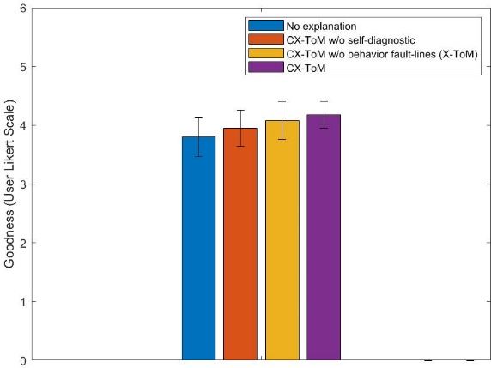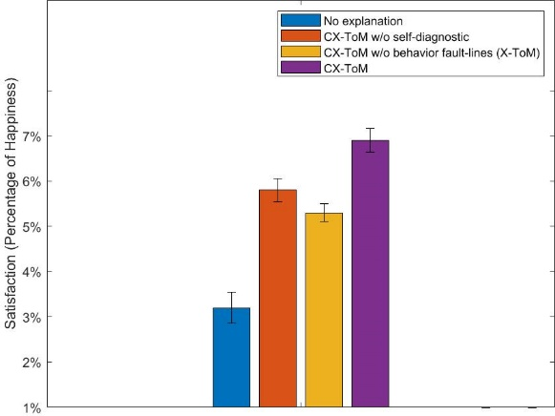

**Figure 5.10: Figure 5.11:**

Quantitative comparison of goodness Quantitative comparison of satisfaction

(More is better) (More is better)

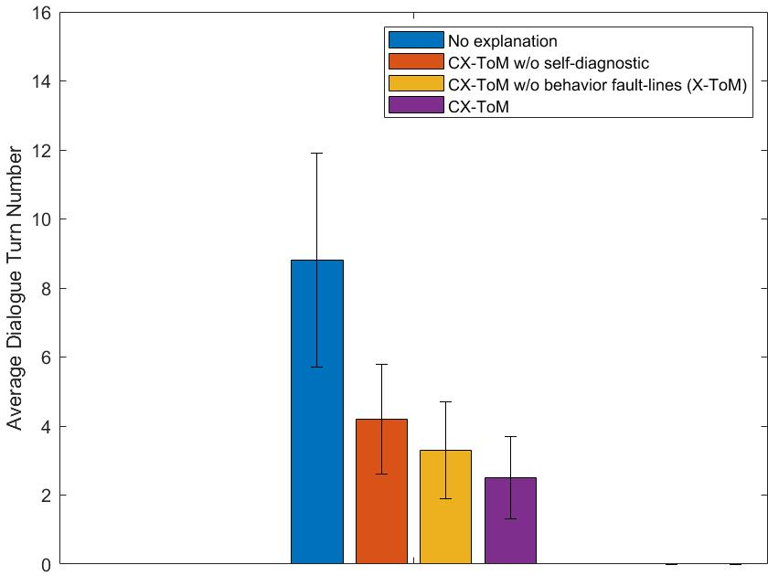

**Figure 5.12:** Quantitative comparison of mental model understanding (Less is better)

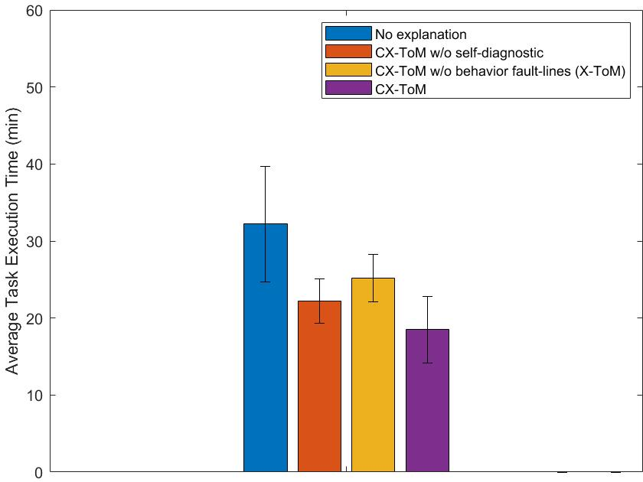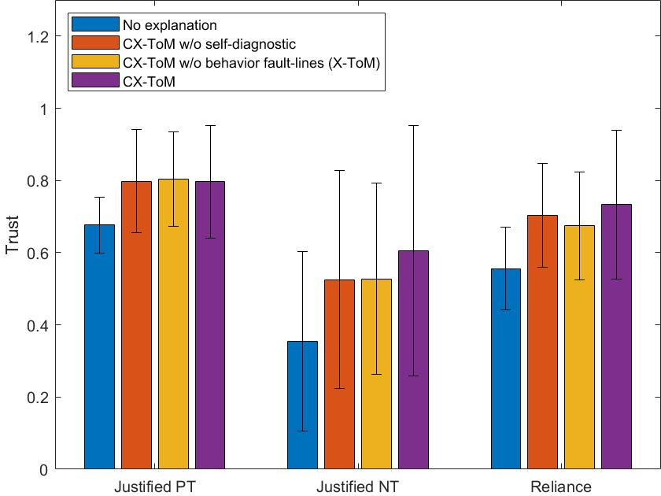

**Figure 5.13: Figure 5.14**:

Quantitative comparison of Quantitative comparison of

user-machine task performance appropriate trust and reliance

(Less is better) (More is better)

Figure 5.13 demonstrates that the experiment group has obtained higher user-machine task performance than both the control group and ablation study group II by large margins in terms of average task execution time (less is better). This confirms our hypnoses H3 that the explanations generated by our CX-ToM can improve the explanation satisfaction and user mental modeling to increase the user-machine task performance.

As for the user appropriate trust and reliance in Figure 5.14, our CX-ToM framework achieves superior gains in trust and reliance in terms of justified positive/negative trust and reliance.

The user idle time (more is better) for all the compared methods are illustrated in the following table. As shown, the user idle time of our CX-ToM significantly outperforms the control group (86.5% vs 33.3%). CX-ToM obtains significantly higher user trust and reliance during the experiment.

|  |  |  |  |  |
| --- | --- | --- | --- | --- |
| **Appropriate Trust and Reliance** | **Control Group**  **(CX-ToM, no explanations to user)** | **Experiment Group**  **(CX-ToM)** | **Ablation Study Group I**  **(CX-TOM, no self-diagnostic)** | **Ablation Study Group II**  **(X-ToM)** |
| Percentage of User Idle Time  *(More is better)* | 33.3±17.9% | 86.5±8.0% | 83.8±2.5% | 79.3±4.3% |

# **Autonomy: Robot Grasping System**

In this task, we developed and examined the performance of an imitation learning system that leverages forces involved in manipulation tasks. This system consists of a glove used to record human poses and forces exerted by the hand. These force-inclusive demonstrations are transferred into robot policies using a learned embodiment mapping and a Temporal And-Or Graph (T-AOG).

**Explanations Provided by Sensory Readings and T-AOG**

First, we use the glove presented in Liu et al. 2018 and the imitation learning framework presented in Edmonds et. al 2017 to learn a robot policy to open various medicine bottles. The learned robot policy consists of two primary components: (i) a bottom-up, sensory feedback component that uses raw haptic feedback from the robot’s gripper to predict which action to execute next and (ii) a top-down, sequential planner that uses a T-AOG to prediction which action to execute next. These two modules are visualized to the human subject as shown below in Figure 6.1. Note that the red on the robot gripper's palm indicates the force applied by the gripper, and these explanations are provided in real-time as the robot executes.

We conducted a psychological study with 150 participants each randomly assigned to one of the five groups; see a summary in Figure 6.2F. Note that all groups observed the RGB video (baseline panel) in addition to their group-specific visualization. For the baseline group, participants only viewed videos of a robot attempting to open a medicine bottle as shown in Figure 6.2A. For the other four groups (see Figure 6.2B-E), participants viewed the same robot video and simultaneously were presented with different explanatory panels on the right side of the screen. Specifically, the full model group viewed the explanatory panel including the real-time robot's symbolic action planning and a force sensing illustration from the robot's manipulator. The text explanation group were provided a text description that summarizes why the robot succeeded or failed to open the medicine bottle *at the end* of the video. The symbolic group viewed the symbolic action planner. The sensory group viewed the force sensing visualization.

After observing robot executions with explanation panels, participants were first asked to provide a rating between 0 and 100 for the question: *to what extent do you* ***trust/believe*** *this robot possesses the ability to open a medicine bottle?* The rating provided a measure of human qualitative trust to the robot's ability to open the medicine bottle. Next, participants were asked to answer an action prediction question based on different segments of actions performed by the robot.



Figure 6.1. Explanations generated by the symbolic task planner and the embodied sensory planner. (A) Symbolic (mechanistic) and sensory (functional) explanations at $a_{0}$ of the robot action sequence. (B), (C), and (D) show the explanations at times $a_{2}$, $a_{8}$, and $a_{9}$, where $a_{i}$ refers to the *i*th action.



Figure 6.2. Explanation panels used in human experiment. (A) Baseline group (RGB video). (B) Symbolic explanation panel. (C) Sensory explanation panel. (D) Text explanation panel. (E) A summary of which explanation components were presented to each group.

**Human Trust and Reliance Results**

Next, we present the results of the human subject experiments. Figure 6.3 shows that for qualitative trust, the text group performs most similarly to the baseline group, while for prediction accuracy, the sensory group performs most similarly to the baseline group. These results indicate the symbolic explanation panel instills the most trust between the robot and the human. The full model and symbolic group foster similar levels of human trust to the robot. Humans appear to need a direct, symbolic explanation of the action sequence in real-time to establish the trust to the machines when performing multi-step complex tasks. Summary text explanations are not sufficient to gain human trust. Similarly, visualizations of haptic feedback, such as those shown in the sensory group, also are insufficient to establish trust.



**Figure 6.3.** Human results for qualitative trust and prediction accuracy. (A) Qualitative trust and (B) action prediction accuracy. The full model performs the best for both measures.

Additionally, we evaluated how well human participants could predict what action the robot would execute next (justified positive trust). Justified positive trust is evaluating by collecting the human subject’s parse graph predictions as the robot is executing and comparing the predicted parse graph with the ground truth parse graph. Action prediction accuracy assesses to what degree explanations facilitate human prediction of robot behavior. All groups provide predictions better than the chance-level performance of 0.125, showing that humans are able to predict the robot's behavior after only a couple of observations about how a robot performs a task. These results on prediction accuracy provide converging evidence that symbolic explanation in real-time is the most effective way for a robot to communicate with humans. These findings highlight the need for explainable AI to provide symbolic interpretations of robot decision-making, rather than visualizations of robot sensor data or summarized text descriptions of behavior.

# **Autonomy: Cooking Game**

The goal of this task is to develop an explainer for an autonomous agent collaborating with a human user. In our daily lives, human collaborators can effectively communicate with their partners to finish a shared task. They can often use their past interactions and their knowledge about each other to guide their communication policies, so team performance can be optimized. We believe robots collaborating with **sub-optimal** human agents should demonstrate similar pedagogic behavior, i.e., robots need to efficiently communicate with humans about the task plan and sometimes persuade humans through convincing explanations. In order to resonate with human’s mind, we jointly model mental states of the robot and human. We set up a user study based on a collaborative cooking task to demonstrate the effectiveness of our framework.

This project focuses on human-machine teaming as a sub-domain for the autonomy research. Specifically, we study how the machine can communicate with a human partner to jointly accomplish complex tasks. The framework we are using has the potential to be applied to situations that are related to real-life combat missions, e.g., search and rescue, bomb defusing. The possible benefits to DoD would be:

* Enabling the machine to comply with human preferences and traits during collaboration.
* Allowing the team to reach a common ground for decision making.
* Improving task performance by properly breaking down a complex task
* Enabling the user to have a right amount of trust on the machine and avoiding the over-trust and lack of trust.

**Overview of the framework**

Inexperienced users often do not have the right expectations for robots. Therefore, they might have sub-optimalplans when collaborating with robots in a shared task. Figure 7.1 shows a simplified example of the task making salad. If the user does not understand the robot’s mind, he/she might take the lettuce from the basket at the beginning (which is closer to him). However, a more optimal plan would be having the user pick up a plate first. In this case, if the robot realizes that the user tries to pick up lettuce, it can issue an explanation to tell the user what it is doing and what it expects the user to do (e.g., taking plate) in the sense of optimizing team performance.

To this end, our framework uses STC-AoGs as hierarchical mind models for both human and robot agents. In particular, a STC-AoG encodes a joint task plan and corresponding spatial, temporal and causal relations (e.g., pre-conditions, post-effects and meaningful temporal order of atomic actions). Figure 7.2 shows an example of using STC-AoG to represent the agent mind model in the task making salad. During collaboration, an agent can use parse graphs ($pg$) to represent the mental states of itself or the other agent. A parse graph is a parse of an And-Or Graph, each of its Or nodes selects one and only one child node. Figure 7.3 shows two parse graphs represent the robot and human’s plan for the situation shown in Figure 7.1.

Explanation is supposed to provide users with necessary knowledge to finish the task efficiently. This can be achieved by inferring user’s mental model during the interaction and comparing it with the machines. Whenever disparity between these two models has been detected, we can generate explanations to encourage correction of user’s mental state, as illustrated in Figure 7.4.

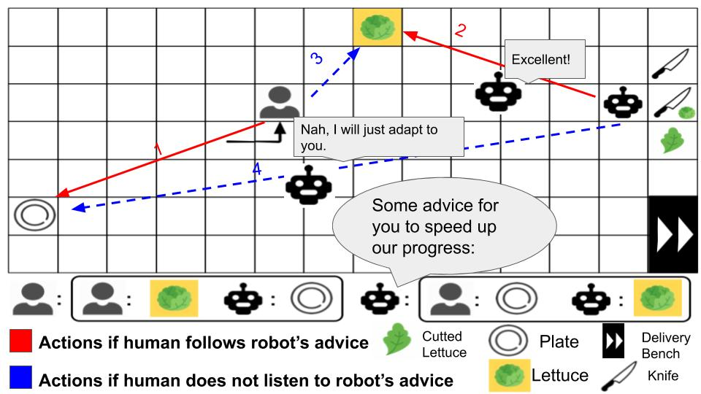

**Figure 7.1**: A robot is collaborating with a human agent to make salad, which require the team to take three lettuce from the basket and cut each one with a knife before putting them onto a plate to serve. At the time being, the first lettuce has been cut and the robot is cutting the second one. Explanations are generated as users are performing sub-optimal actions (going to the lettuce).

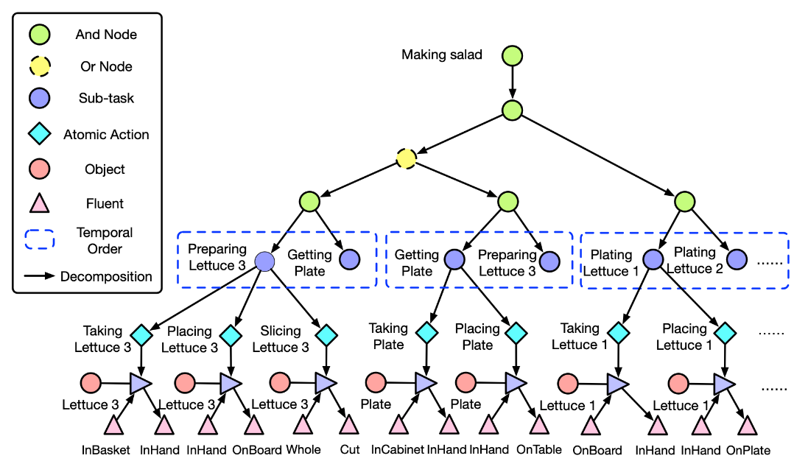

**Figure 7.2**: The hierarchical mind model for the collaboration task, making salad, represented by an STC-AoG. The Or node (shown as the yellow circle) represents two possible ways for the team to finish the tasks.

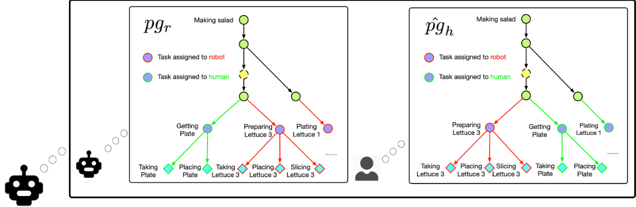

**Figure 7.3:** Robot mental state and inferred human mental state represented as parse graphs.

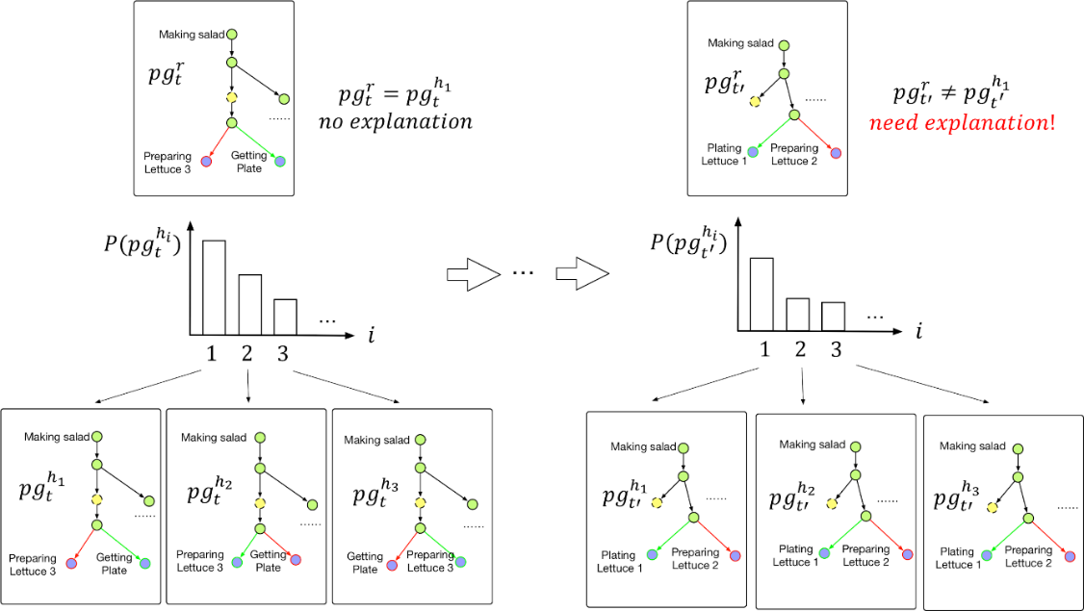

**Figure 7.4:** Explanations are generated when there is a mismatch between agents’ mental states.

**Experiments**

To demonstrate the effectiveness of our algorithm in human-robot teaming, we conducted a user study in a game-like virtual cooking environment, where participants could collaborate with agents. Our experiment domain is inspired by the popular video game Overcooked, where multiple agents are supposed to make use of various tools and take different roles to prepare, cook and serve a number of dishes. As illustrated in Figure 7.5 and Figure 7.6, we use Unreal Engine 4 to create a cooking task (making apple), as well as the explanation interface. Team members are supposed to take apples from the box and slice them with a knife near the chopping board. Three apple slices should be placed into the juicer before apple juice can be produced and delivered to the delivery bench.

We use a between-subject design for the study. Users are randomly assigned to one of three groups and receive different explanations from the robot:

**Control:** Users would not get any explanations from the robot. As a result, they can learn to finish the task by interacting with the environment.

**Heuristics:** The robot gives explanations when there are no detected user actions for a period of time. This serves as a simple heuristic for the robot to infer whether users are having difficulties in finishing the task.

**Mind Modeling:** The robot gives explanations when there is a disparity between robot and inferred human mental state.

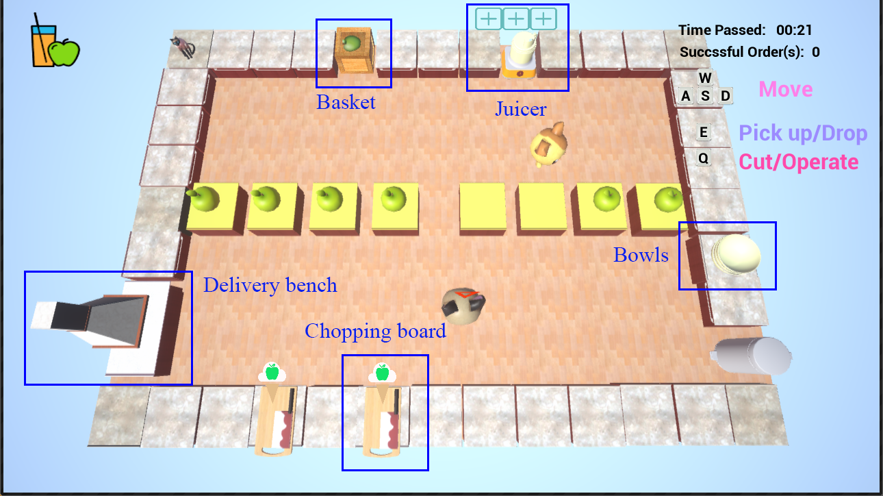Our objective measurement is intended to evaluate the human-robot teaming performance and subjective measurement is designed for evaluating the user's explanation satisfaction.

**Figure 7.5:** A top-down view of our collaborative cooking game, where the user (the bottom character) collaborates with a robot (the top character) to make apple juice.

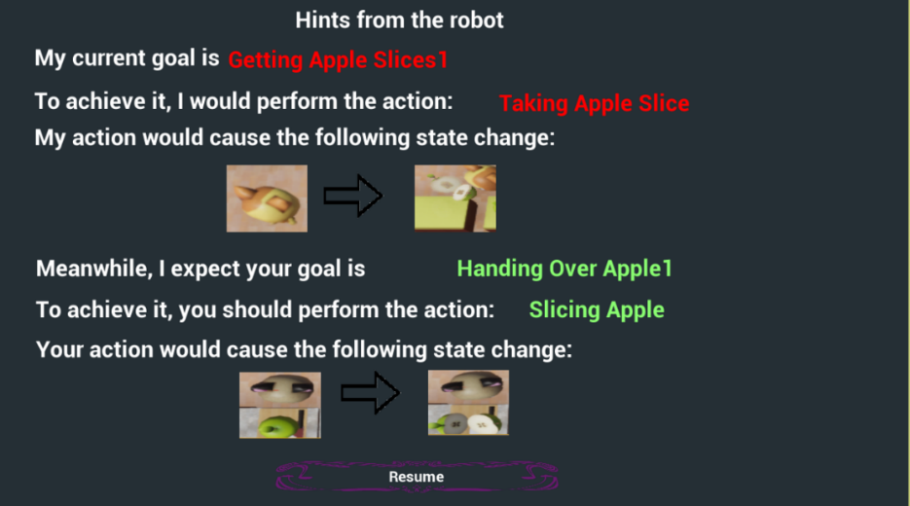

**Figure 7.6:** The explanation interface shows user the expected sub-tasks and atomic actions for both agents. Pre-conditions and post-effects of atomic actions are displayed as well.

**Experimental Results and Analysis**

We recruited 27 subjects for our IRB-approved study from the UCLA Psychology and UCLA Communications subject pools. All the participants had moderate experience with video games and have not played the video game "Overcooked", which inspired our study design. In addition, we did not include data of two participants from the control group for task completion time, as they failed to finish the designated task in 10 minutes. Generally, we used ANOVA to test the effects of different experimental conditions on teaming performance trust and subjective perception of explanation. Tukey HSD tests were conducted on all possible pairs of experimental conditions.

As shown in Figure 7.7, we found significant effects from "mind modeling" conditions on the completion time of the first order. However, for the completion time of the second order, we did not find any significant effect. This is not surprising since users were asked to finish the same task in the first and second order. Users could take advantage of their previous experience working with the robot. The factorial ANOVA also revealed a significant effect on the perceived helpfulness and efficiency of the explanation system.

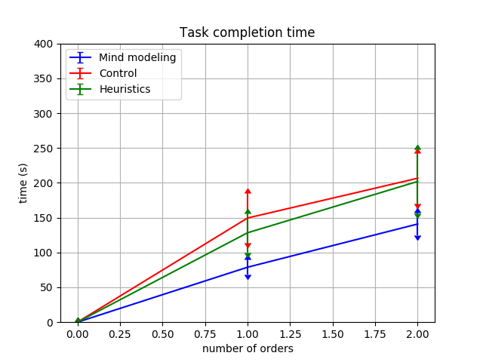

**Figure 7.7:** Time taken for the team to complete two orders under different testing conditions.

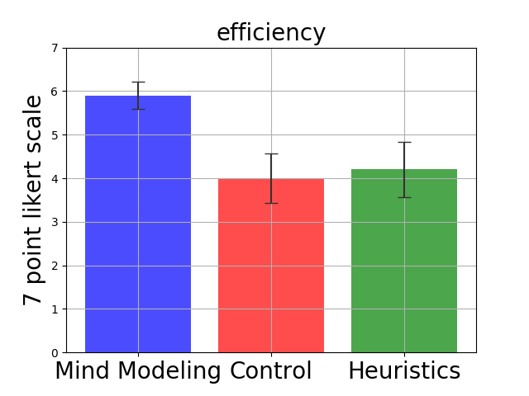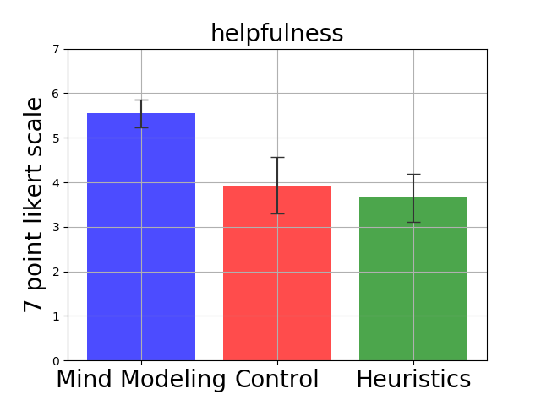**Figure 7.8:** User’s self-reported explanation satisfaction in terms of efficiency and helpfulness.

# **Autonomy: Robot Scout Exploration Game**

We devise a human-machine teaming system presented as a collaborative game, in which the human user needs to work together with a group of robot scouts to accomplish some tasks and optimize the group gain. In this game, the human user and robot scouts communicate on a constrained channel: Only the robot team directly interacts with the physical world; the human user does not directly access the physical world or direct control over robot scouts’ behavior. Meanwhile, only the human user has access to the ground-truth value function of the task (e.g., minimize overall time); the robot team must infer this value function through human-machine teaming. Such a setting realistically mimics real-world human-machine teaming tasks, as many systems perform autonomously in dangerous settings under human users’ supervision. The XAI system is expected to provide appropriate explanations to justify its behaviors and gain human user’s trust and reliance. This process is achieved by actively inferring the human user’s mental model (i.e., value and utility as the instantiation of the belief, desire, and goals) during the game. Therefore, the system’s explanation generation is a bidirectional dialogue framework: The XAI system needs to both “speak” and “listen”—explaining what it has done and plans to do based on its inference of the human user’s value and utility. In the meantime, the human user is tasked to command robot scouts to reach the destination while maximizing the team’s score. Hence, the human user’s evaluation of the XAI system is also a bidirectional process: The human user has to infer the goal of robot scouts and check if it aligns with the given value function of the task. Ultimately, if the XAI system works well, the robot scout value function should align well with the ground-truth value function given only to the human user, and the human user should gain high trust from the XAI system. Our methodology studies XAI in a full-blown communication system, a combination of our previous XAI work on autonomy, including theory-of-mind, communicative learning, value-alignment, and causal reasoning for effective explanation generation.

Our design encourages natural human-machine teaming and bidirectional reasoning as both parties have crucial but private information at the beginning of the game. The robot scouts possess information about the map but lack access to the human user’s value function, which determines mission goals, hindering the robot scouts’ ability to make proper decisions that reflect the human user’s intent. Meanwhile, the human user, who knows the task’s value function that governs the decision-making process, lacks direct access to the environment. By allowing constrained communication to fulfill human-machine collaboration, the robot scouts can make sporadic action proposals to the human user, and the human user provides a binary accept/reject feedback, which the robot scouts will then utilize to infer the human user’s value function and adjust robot scouts’ behaviors accordingly. Based on adjusted behavior, the human user will provide ratings or the trust/reliance of the XAI system. In our setting, the communication’s main purpose is to align the value function between the human user and the robot scouts. For a fast alignment, the robot scouts need to know when and how to make proposals, such that feedback from the user is most informative to estimate the value function correctly. To obtain instructive feedback from the human user, the robot scouts must establish a shared agency or common mind—what the human user knows and believes, what the human user intends to do, and what are aligned and misaligned. Only based on this shared agency could the robot scouts provide explanations that properly justify previous actions and current proposals. Besides the value alignment process, our design also involves estimation of human user’s utility, i.e., the human user’s preference of the forms of explanations. In contrast to the objective value function given to the human user, this utility-driven human user’s preference is subjective and more likely to be individually different. We argue that a properly modeling of such an individual difference plays a crucial role in gaining human trust and reliance. The human user’s value function and utility together form the human user’s mental state.

**Game Setting**

Our collaborative game, Robot Scout Exploration Game, has a minimal design and involves one human commander and three robot scouts. The game’s objective is to find a safe path on an unknown map from the base (located at the bottom right corner of the map) to the destination (located at the upper left corner of the map). The map is represented as a partially observed 20×20 tile board, with each tile potentially holding one of the various devices and remain unobserved until a robot scout moves closer to it. We define a set of goals for the robot scouts to pursue as they find the path to reach the destination, including (i) saving time used to reach the destination, (ii) investigating suspicious devices on the map, and (iii) exploring tiles, and (iv) collecting resources. The game’s performance is measured by the accomplishment of these goals by the robot scouts and their relative importance (weights), defined as the human user’s value function.

Again, this value function is only revealed to the human user, not the robot scouts. One comparable but different setting to our human-machine teaming framework is the inverse Reinforcement Learning (RL). Inverse RL aims to recover an underlying reward function given pre-recorded expert demonstrations in a passive learning setting. In contrast, the agent (the collective form of all robot scouts) in our system is designed to interactively learn from scarce supervisions given by the human user. Crucially, our design requires the agent to actively infer human user’s mental model (value and utility) to cooperatively accomplish a task, a unique proper of human-centric learning scheme. In a nutshell, the agent is tasked to perform value-alignment by inferring human user’s mental model, actively make proposals, and evaluate the human user’s feedback, requiring complicated and recursive mind modeling of the human user.

**Experiments**

Subjects/Participants for this study were recruited from the online Prolific user research platform. Participants were selected based on their location (in the United States), their highest level of education (at least a bachelor’s degree), and the device they were using (no mobile users were selected). This choice was made to confine our participants to a population that is more likely to understand the nuance of the game while maintaining a broad pool of participants that is representative of the general population. A desktop/laptop computer was required to interact with the game appropriately. Information on the participants’ computer was collected (i.e. User-Agent). No other demographic information from the participant was collected after passing our demographic selection criteria.

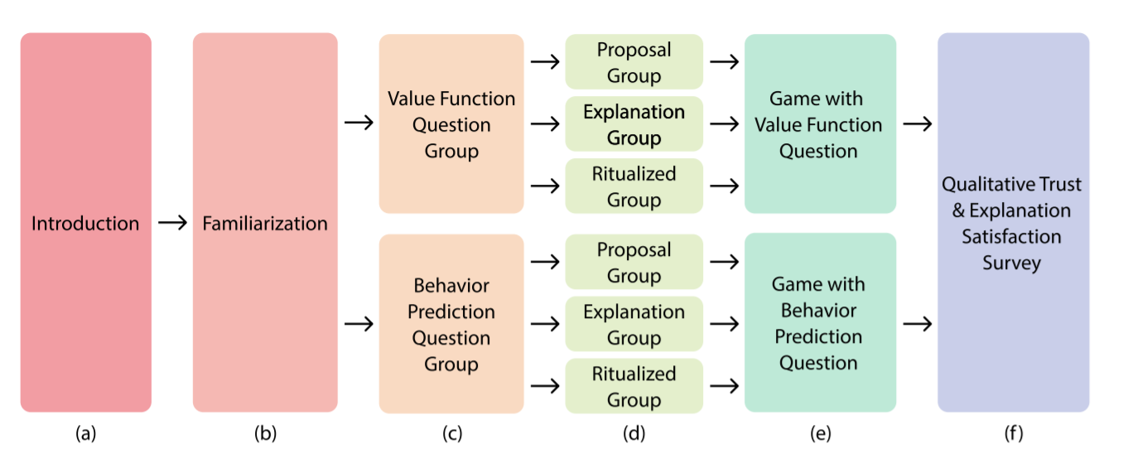

**Figure 8.1**: User study flow. (a) Participants begin with an introduction to explain the setting and define key terms. (b) Participants are then familiarized with the game interfaces, and a questionnaire is given to verify participants understand the game. Participants that did not pass the familiarization were removed from the study. (c) Participants are randomly split into two groups: a group that is asked to infer the robot scout’s current value function and a group that is asked to predict the robot scout’s next behavior. This is done in a between-subject design. (d) Participants are further randomly split to receive different forms of explanations: proposals, explanations, and ritualized explanations. This is done in a between-subject design. (e) The participants then play the game and are asked the question assigned to their group throughout the experiment. (f) After finishing the game, participants were asked qualitative trust and explanation satisfaction questions

After participants finished introductory material, a 7-question familiarity test was given to participants before proceeding into the game. This check was to make sure participants understood the rules of the game, what their objectives were, how to interpret value functions, and the distinction between explanations and proposals. Participants passed the questionnaire if they answered every question correctly. If a participant missed a question, a page was shown to explain the correct answer. Participants that missed a question had to repeat the entire questionnaire, and participants that failed to pass the questionnaire twice were removed from the study. Participants were assigned randomly to each condition and were balanced automatically by our survey platform (Qualtrics). Compensation started at $10 USD per participant, and our scoring system incentivizes participants to score as many points as possible. Participants received $0.05 USD per point in the game, with a maximum total payout of $20 USD per participant. The study was conducted in a between-subject design.

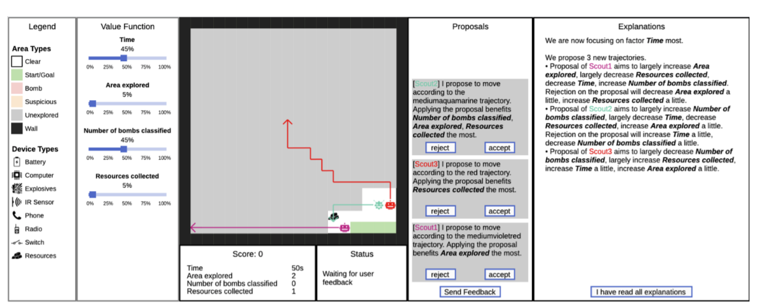

**Figure 8.2**: User interface of the scout exploration game. Moving from left to right, the Legend panel displays a permanent legend for the user to refer to understand different tile types. The Value Function panel shows the current value function of the user’s team, is unknown to the robot scouts, and cannot be modified by the user. The central map shows the current information on the map. The Score panel shows the user’s current score and the individual fluent functions that contribute to the score. The overall score is calculated as the normalized, value function-weighted sum of the individual fluent function scores. The Status panel displays the current status of the system. The Proposal panel shows the robot scouts’ current proposals, and the user can accept/reject each. The Explanation panel shows explanations provided by the scouts.

The introduction phase of the experiment introduces the basic background of the game. The introduction outlines that the participant is a commander in charge of finding a path from the lower-right-hand corner of the map to the upper-left-hand corner of the map. The introduction outlines that the area may have dangerous devices, such as bombs, along the path. The participant is told they have a team of robot scouts to help explore the area, and that the scouts will provide proposals (and in explanation groups, explanations).

During familiarization, the participant is instructed that while their objective is to get to the upper-left corner, they are also instructed there are sub-goals the team would benefit from achieving. These sub-goals consist of time, area explored, number of bombs investigated, and the resources collected. Participants are then informed that these goals are specific to the team’s current circumstance and the value function conveys the relative importance of these sub-goals. Participants are informed they will be scored, and this score is weighted by the value function. Finally, the robot scout proposals and explanations are described. Proposals correspond to robot scout plans, and explanations attempt to justify those plans. These various components are

**Figure 8.3**: Example interfaces for the value function question and the behavior prediction question. (a) Users can slide the bars to set a relative importance of each sub-goal. The sub-goals must sum to 100%. As the user changes one slider, the others will automatically decrease to keep the sum at 100%. Users can lock a particular slider by checking the lock symbol to the right of the slider. (b) Users are asked to predict which sub-goal the robot scouts will pursue next. Users are asked to predict the sub-goal for each scout individually; this is because proposals are generated on a per-scout basis.

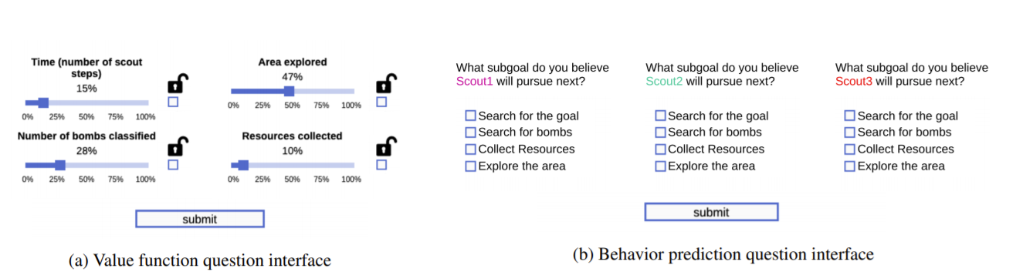introduced using figures of the panels shown in Fig. 8.2. To test the participant’s understanding of the background, at the end of the familiarization phase, the participant is given several attention-check questions at the end of familiarization. For example, we asked “for each trial, you will be given a value function that describes the team’s current mission priorities” (correct answer: true). Participants who answered a question incorrectly would receive instruction as to why the correct answer is correct and would be required to repeat the attention-check. Participants who failed the attention-check twice did not further participate in the study.

We implemented this game using HaxeFlixel, a 2D Game Engine used to create JavaScript-based games. Users can access the game on web browsers. The full user interface of the game is displayed in Fig. 8.2. Throughout the study, the user monitors the progress of the team, receives explanations, and gives feedback by accepting or rejecting the proposals. The team’s performance is quantified as a score, which reflects how well the scouts can estimate the user’s value function and act accordingly. Participants are instructed to maximize the team’s score. The score is weighted by the value function to appropriately score the relative importance of sub-goals. Each sub-goal score is computed from the environment’s reward function. During the game, the robot scouts attempt to infer the human value function. To infer the correct value function, the robot team proposes action plans to the user and estimates the value function based on the user’s feedback. Explanations of the proposals will accompany to better clarify the motivation of the robot scouts. An example proposal is: “We can keep moving despite the suspicious area (proposal) if we want to find a path from A to B as soon as possible (explanation).” If the user accepts this proposal, the robots will increase the value of time in the value function. Otherwise, the robots will increase the value of investigating bombs and tile exploration but decrease the value of time. The game repeats in a loop, where robot scouts make proposals (and in some groups, explain), execute plans, and repropose until they find a path to the upper-left-hand corner of the map.

After the participants finish the game, they are directed to a post-experiment survey to evaluate qualitative trust and explanation satisfaction. Self-reported trust is evaluated using Likert-scale questions, which are designed based on Muir’s questionnaire and Madsen’s Human-Computer Trust Instrument. The questionnaire intends to evaluate how the information given to the users across different groups helps them make appropriate decisions when they are asked to give feedback on the proposals. Such appropriate reliance is supported by a correct understanding of multiple components of the system, including the planning, value function estimation, proposal generation, feedback interpretation, and/or explanation generation, which form the basis of trust. Specifically, the trust questionnaire is composed of questions that intend to evaluate the perceived reliability, technical competence, and understand-ability of the scouts with respect to these components. We ask the users “how much would you trust the robot scouts to achieve a high score on their own, given they have the correct value function?” and “how much do you trust the robot scouts to learn the value function of another commander in another circumstance?” Explanation satisfaction is evaluated in the aspects of transparency, helpfulness and timeliness via Likert-scale questions to reflect users’ feeling on how well the explanation has helped them understand these components and make correct feedback to guide the team towards plans that better suited to the scenario and value function given to the users.

**Hypotheses**

The hypotheses we are testing in this experiment are related to quantitative measures for mental model alignment and qualitative measures relating to trust and explanation satisfaction. The quantitative measures for mental model alignment include: (H1) value function alignment, (H2) behavior prediction, and (H3) user-machine task performance. For value function alignment (H1), we hypothesize that groups that have access to explanations will be more accurate inferring the current robot scout value function. For the behavior prediction (H2), we hypothesize that groups that have access to explanations will be more accurate in predicting what the robot scouts will do next. The user-machine task performance (H3) will be evaluated by the score participants receive from the game.

Our qualitative measures will assess trust by asking users whether they would trust the robot scouts to complete the task on their own, given they have the correct value function. Additionally, we will ask users whether or not they trust the scout to learn a different value function with a different commander. We hypothesize that groups that have access to richer explanations will rate the qualitative trust measures higher than those without (H4). Our second qualitative hypothesis (H5) is that groups with access to richer explanations will report higher degrees of explanation satisfaction.

**Results**

Our results section is notably incomplete. We are still waiting for approval from HRPO on the IRB for this project. We have answered every request relating to the IRB as quickly as possible, typically within hours. Note that our UCLA IRB has been approved since early October after submitting in early September. Per DARPA policies and instructions, we are not permitted to run participants until we have HRPO approval. However, we are still polishing and refining the user study and computational model, so the time is not wasted.

Here we outline how we plan on analyzing the results. Our primary measures of significance will be using a student’s t-test and analysis of variance (ANOVA) using the F-test. We expect to see the following significance’ for each hypothesis:

• H1: Significance between proposal and explanation group. Significance between proposal and ritualized explanation group. No significance between explanation and ritualized explanation group.

• H2: Significance between proposal and explanation group. Significance between proposal and ritualized explanation group. No significance between explanation and ritualized explanation group.

• H3: Significance between proposal and explanation group. Significance between proposal and ritualized explanation group. No significance between explanation and ritualized explanation group.

• H4: Significance between proposal and explanation group. Significance between proposal and ritualized explanation group. Significance between explanation and ritualized explanation group. • H5: Significance between proposal and explanation group. Significance between proposal and ritualized explanation group. Significance between explanation and ritualized explanation group.

We believe for H1 and H2, we will observe significance between the proposal and explanation group. This is predominately due to the richer explanations providing a deeper insight into the robot scout’s reasoning process, allowing better inference of the mental state of the robot scouts. The same applies between the proposal and ritualized explanation group. We do not expect to see a significance between the explanation and ritualized explanation for these hypotheses because these two forms of explanation convey similar information in different forms (ritualized being an abridged version of the full explanation based on the common mind between the human and the robot scouts).

For H3 and H4, we believe to see significance between all groups. Between the proposal and explanation group, we believe the transparency and insight provided by the explanations will improve trust and satisfaction ratings. Furthermore, between the explanation and ritualized explanation group, we predict the ritualization will further improve trust and satisfaction ratings, as the ritualization conveys a deeper understanding of the shared common mind between the human and the robot scouts.

# **Selected Publications from June 2017 to April 2021**

(Some are highlighted in red with “**[IMP]**” because they are directly on XAI, other papers are related to XAI)

1. [IMP] A. Akula, K Wang, C. Liu, S. Saba, H. Lu, S. Todorovic, J. Y. Chai, S-C. Zhu, “X-ToM: Explaining with Theory-of-Mind for Gaining Justified Human Trust”,iScience Cell Press **(**minor revision) 2021.
2. [IMP] A. Akula, S. Wang, S-C. Zhu, “CoCo-X: Generating Conceptual and Counterfactual Explanations via Fault-Lines”,Proceedings of the AAAI Conference on Artificial Intelligence (AAAI), 2020.
3. [IMP] Q. Zhang, X. Wang, Y. N. Wu, H. Zhou, and S-C. Zhu, “Interpretable CNNs for Object Classification”, IEEE Transactions on Pattern Analysis and Machine Intelligence (PAMI), Accepted, 2020.
4. [IMP] M. Edmonds*, F. Gao*, H. Liu*, X. Xie*, S. Qi, B. Rothrock, Y. Zhu, Y.N. Wu, H. Lu, and S.-C. Zhu, “A Tale of Two Explanations: Enhancing Human Trust by Explaining Robot Behavior”, Science Robotics, Vol. 4, No. 37, eaay4663, 2019.
5. [IMP] A. Akula, S. Gella, O. Yaser, S. Reddy, S-C. Zhu, “On the Robustness of Visual Referring Expressions”,submitted to Association for Computational Linguistics (ACL) 2020.
6. [IMP] Q. Zhang, J. Ren, G. Huang, R. Cao, Y. N. Wu, and S-C. Zhu, “Mining Interpretable AOG Representations from Convolutional Networks via Active Question Answering”, IEEE Transactions on Pattern Analysis and Machine Intelligence (PAMI, under minor revision), 2020.
7. [IMP] Q. Zhang, X. Wang, R. Cao, Y. N. Wu, F. Shi, and S-C. Zhu, “Extracting an Explanatory Graph to Interpret a CNN”, IEEE Transactions on Pattern Analysis and Machine Intelligence (PAMI, under minor revision), 2020.
8. M. Edmonds, X. Ma, S. Qi, Y. Zhu, H. Lu, and S.-C. Zhu, “Theory-based Causal Transfer: Integrating Instance-level Induction and Abstract-level Structure Learning”, Proceedings of the AAAI Conference on Artificial Intelligence (AAAI), 2020.
9. W. Wang*, H. Zhu*, J. Dai, Y. Pang, J. Shen, L. Shao, “Hierarchical Human Parsing with Typed Part-Relation Reasoning”, Proceedings of IEEE Conference on Computer Vision and Pattern Recognition (CVPR), 2020.
10. J. Li and S. Todorovic, “Set-Constrained Viterbi for Set-Supervised Action Segmentation”, Proceedings of IEEE Conference on Computer Vision and Pattern Recognition (CVPR), 2020.
11. T. Yuan, H. Liu, L. Fan, Z. Zheng, T. Gao, Y. Zhu, and S.-C. Zhu,” Joint Inference of States, Robot Knowledge, and Human (False)-Beliefs”, International Conference on Robotics and Automation (ICRA), 2020.
12. [IMP] S. Yang and J. Y. Chai. “Deep Factorized Network for Grounded Action Justification”, Submitted to Conference on Empirical Methods in Natural Language Processing (EMNLP).
13. [IMP] S. Storks, Q. Gao, and J. Y. Chai. “Commonsense Reasoning in Natural Language Understanding: A Survey on Benchmarks, Resources, and Approaches”, Submitted to Journal of Artificial Intelligence Research. 2019.
14. [IMP] Y. Yu, K. Wang, S-C. Zhu, “Improving Network Interpretability via Explanation Consistency Evaluation”,submitted to IJCAI 2020.
15. W. Zhang, C. Zhang, Y. Zhu, and S.-C. Zhu, “Machine Number Sense: A Dataset of Visual Arithmetic Problems for Abstract and Relational Reasoning”, Proceedings of the AAAI Conference on Artificial Intelligence (AAAI), 2020.
16. [IMP] A. Akula, C. Liu, S. Todorovic, J. Y. Chai, S-C. Zhu, “Explainable AI as Collaborative Task Solving”, IEEE Conference on Computer Vision and Pattern Recognition (CVPR) Workshops 2019.
17. [IMP] A. Akula, S. Todorovic, J. Y. Chai, S-C. Zhu, “Natural Language Interaction with Explainable AI Models”,IEEE Conference on Computer Vision and Pattern Recognition (CVPR) Workshops 2019.
18. C. Zhang*, B. Jia*, F. Gao, Y. Zhu, H. Lu, and S.-C. Zhu, “Learning Perceptual Inference by Contrasting”, Neural Information Processing Systems (NeurIPS), 2019.
19. [IMP] X. Xie, H. Liu, Z. Zhang, Y. Qiu, F. Gao, S. Qi, Y. Zhu, and S.-C. Zhu, “VRGym: A Virtual Testbed for Physical and Interactive AI”, Association for Computing Machinery Turing Celebration Conference (ACM TURC), 2019.
20. K. Nguyen and S. Todorovic, "FAPIS: A Few-Shot Anchor-free Part-based Instance Segmenter," submitted to European Conf. Computer Vision (ECCV 2020), Glasgow, UK, 2020
21. J. Li and S. Todorovic, "Anchor-Constrained Viterbi for Set-Supervised Action Segmentation," submitted to European Conf. Computer Vision (ECCV 2020), Glasgow, UK, 2020
22. L. He and S. Todorovic, "Learning Affinities of Disappearing and Re-appearing Objects in Online Multiobject Tracking," submitted to European Conf. Computer Vision (ECCV 2020), Glasgow, UK, 2020.